**Date-13-Aug-2021**

Task: To Make All The Program in Javascript

1. Calculate area of a rectangle.

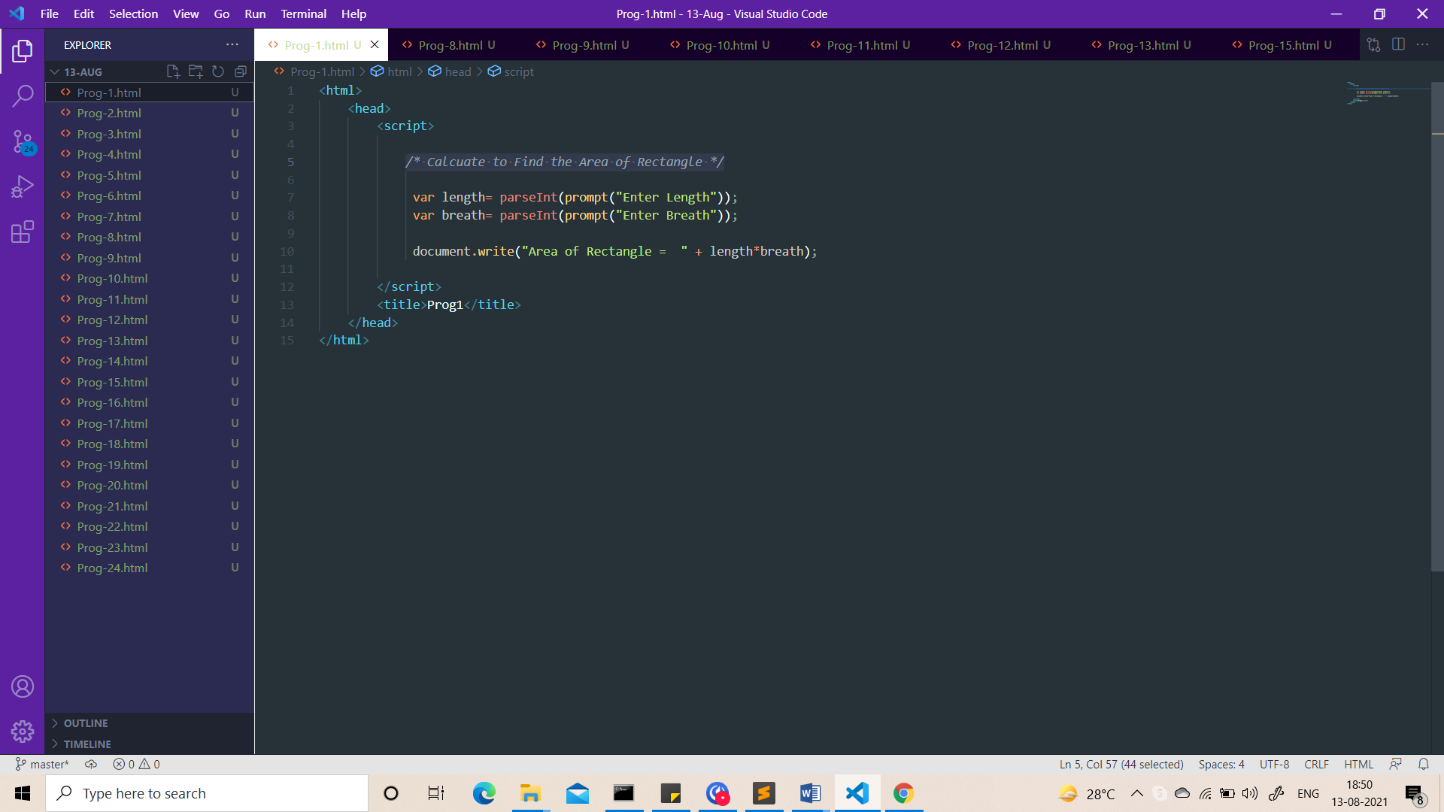  
  
Output:  
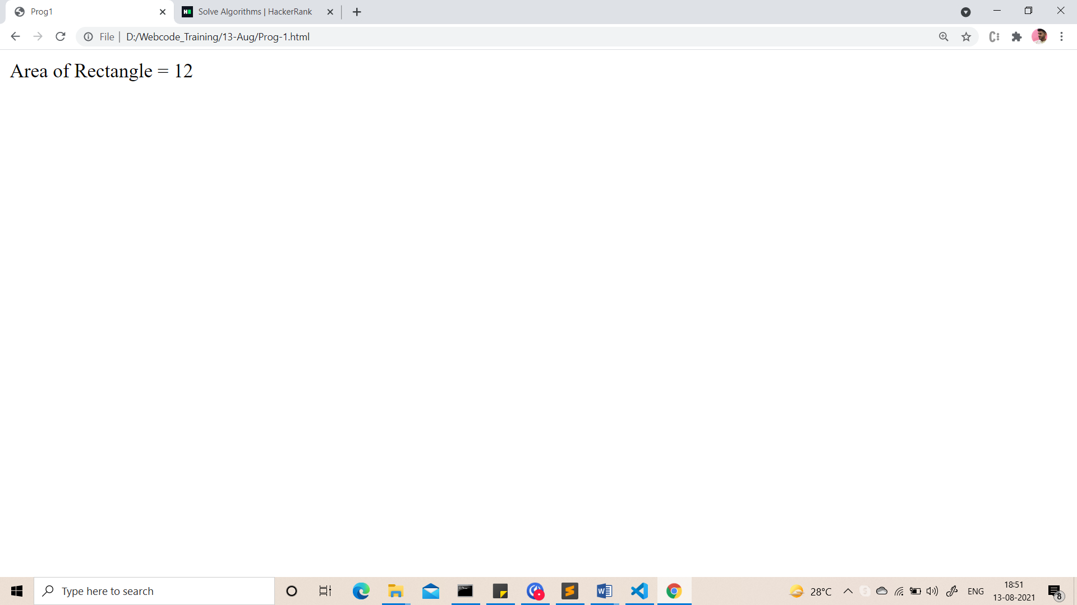

1. Calculate area of a square

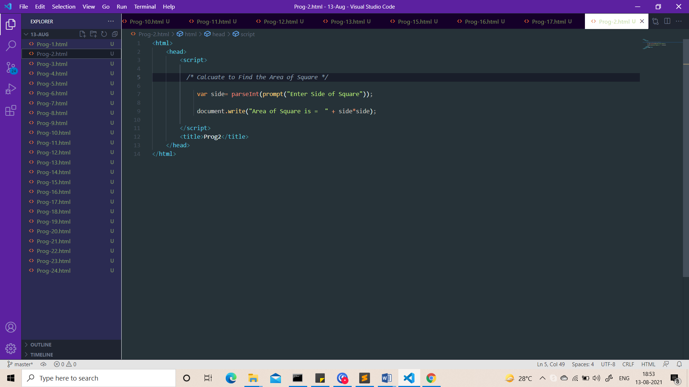

Output:-

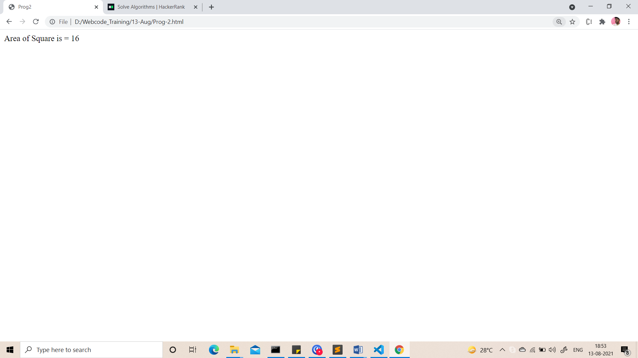

1. Calculate area of a circle.

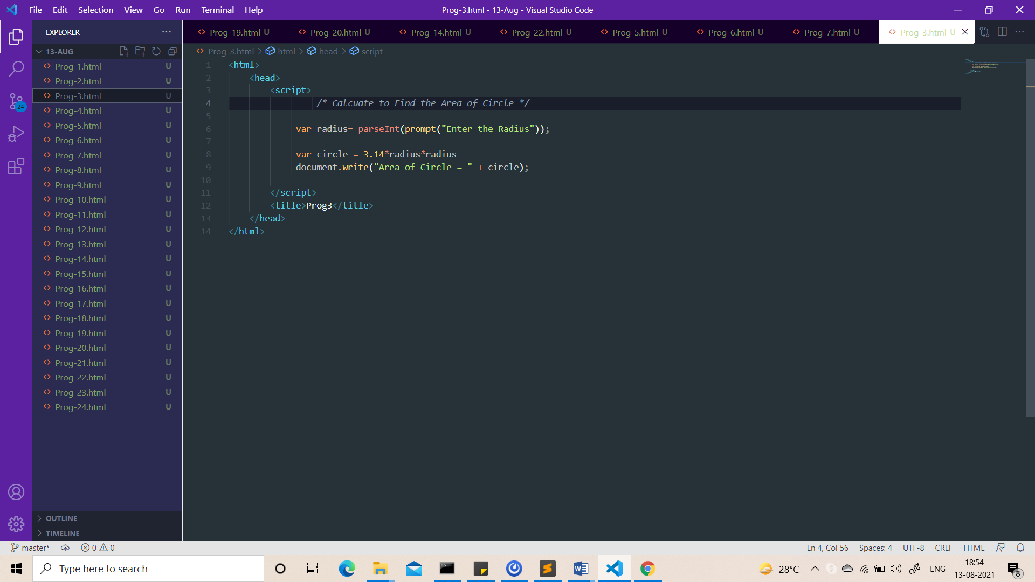

Output:-

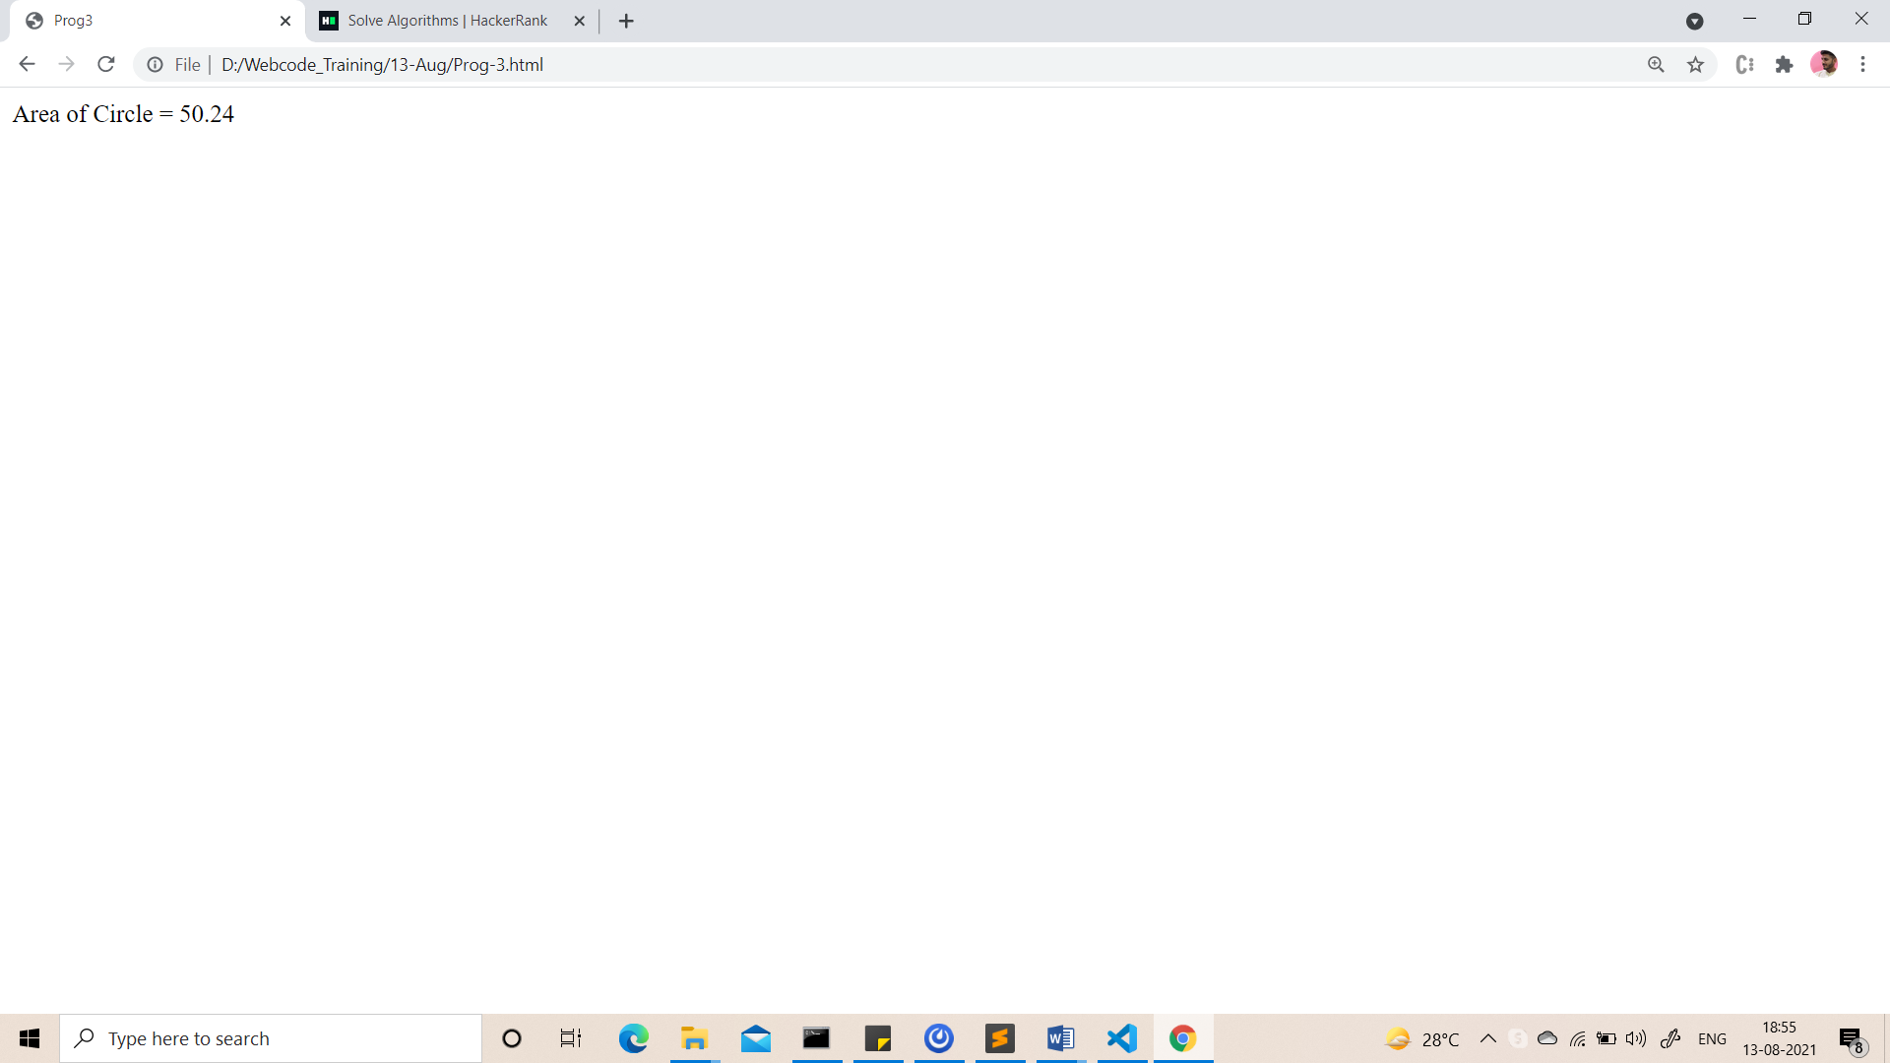

1. Calculate average of 5 numbers.

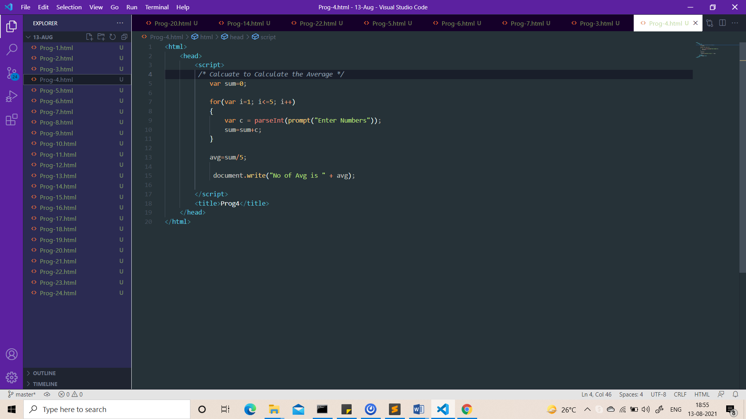

Output:-

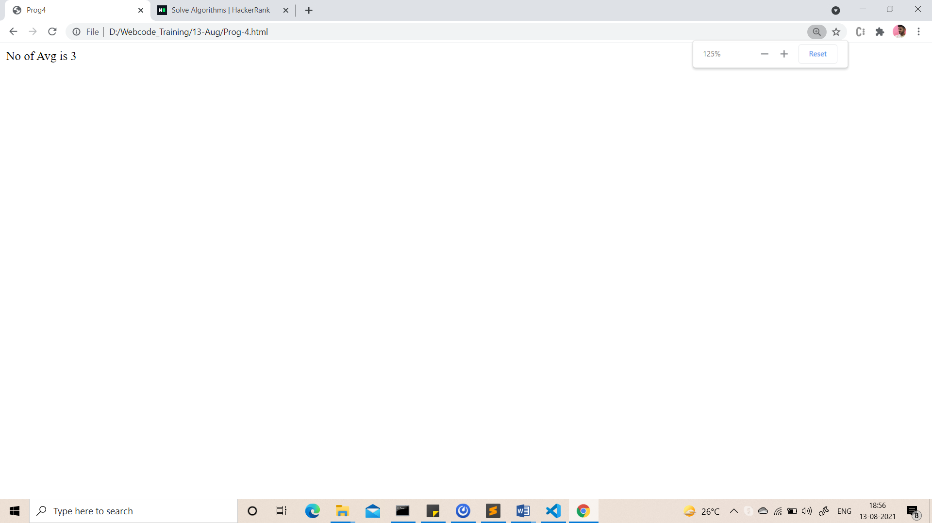

1. Check whether number is even or odd.

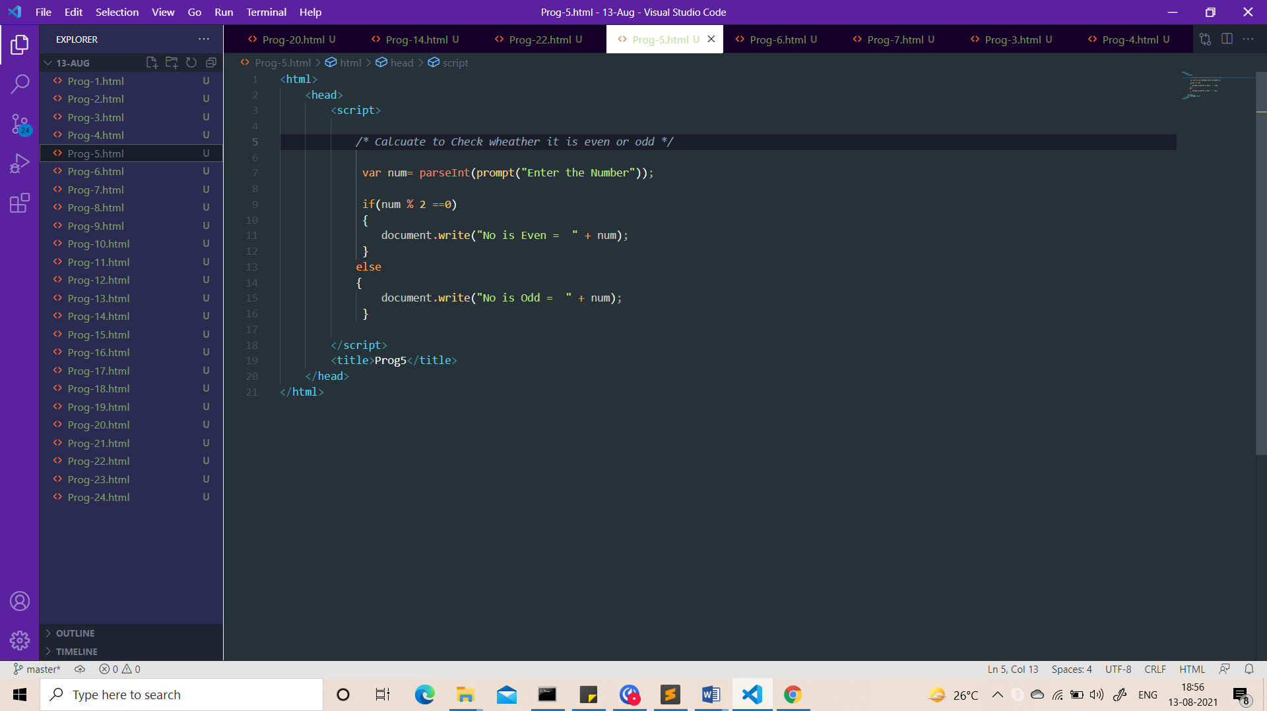

Output:-

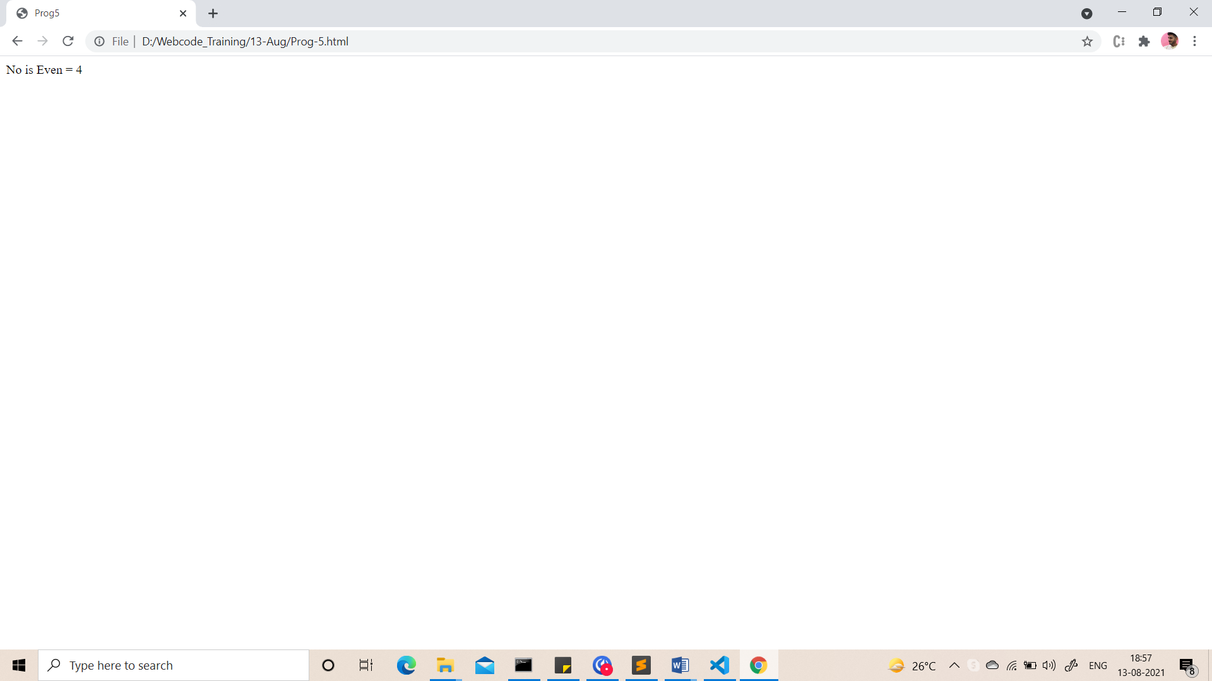

1. Take a year and check whether it is leap year or not

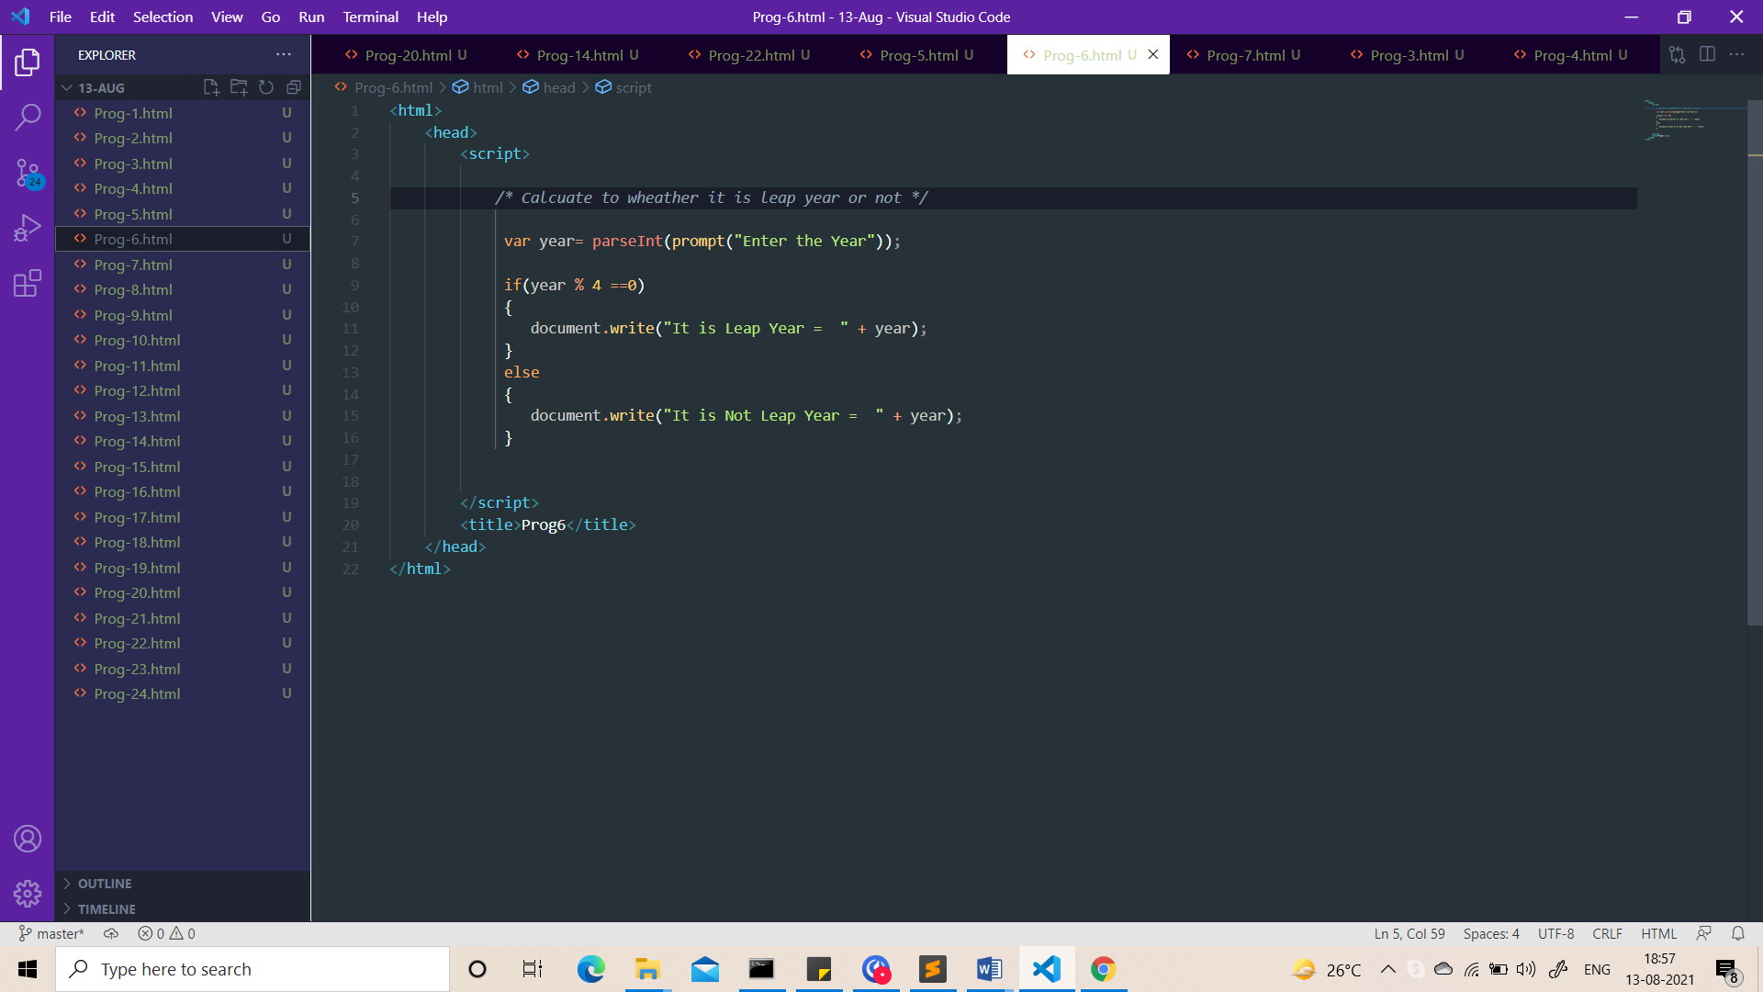

Output:-

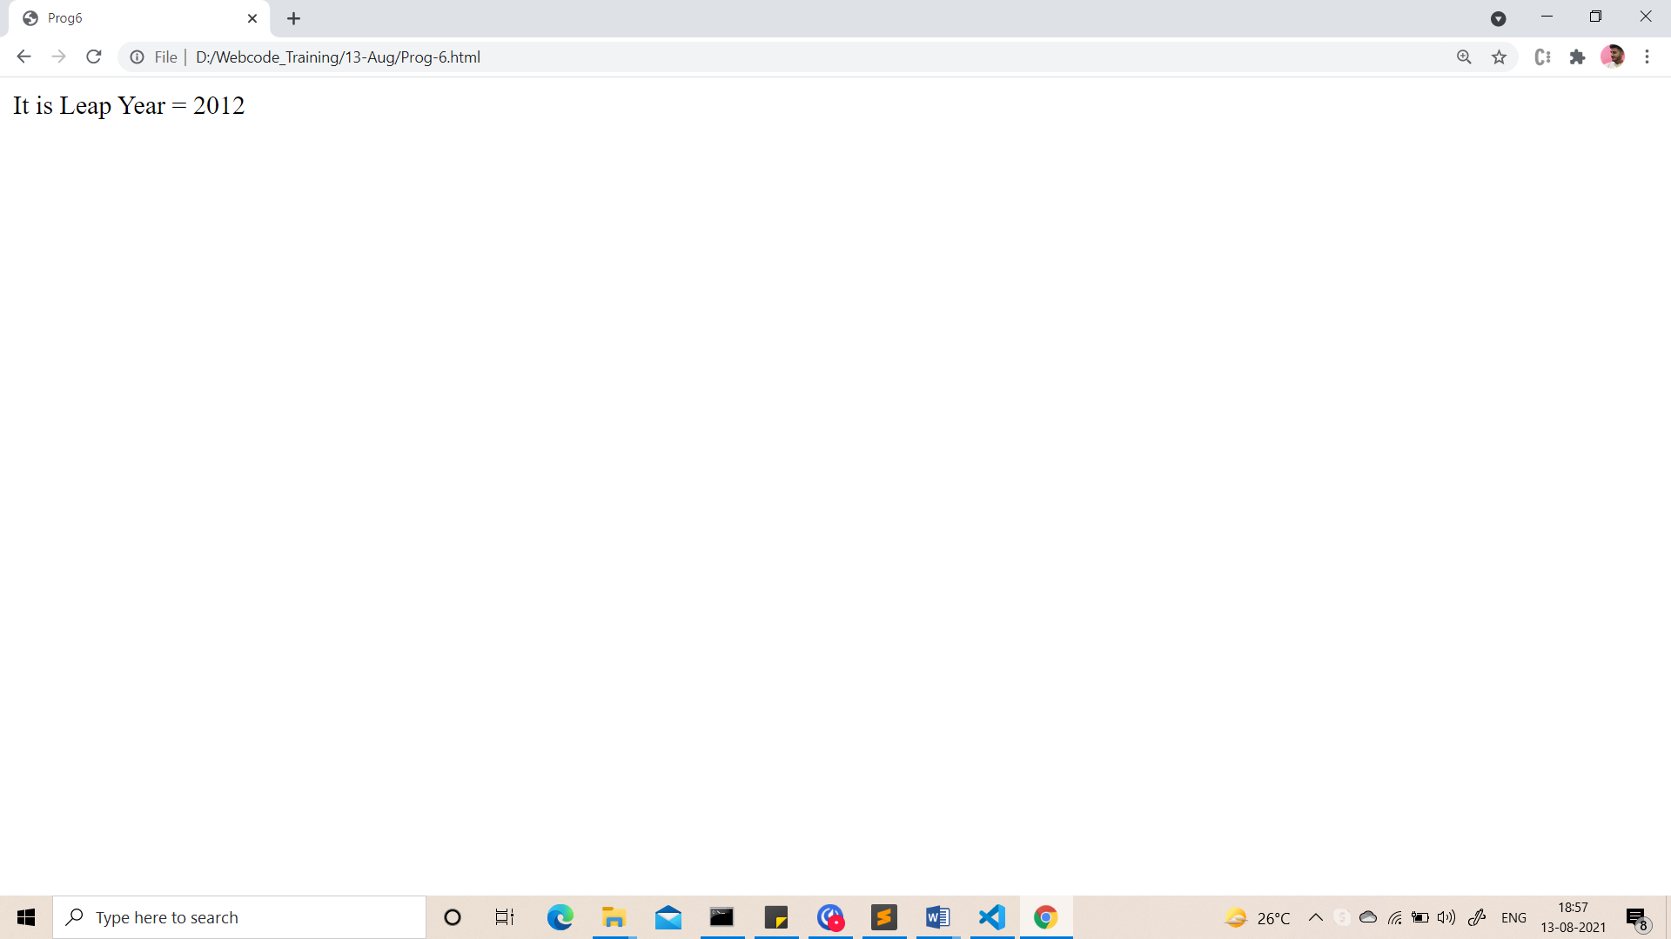

1. Take a number and check whether it is zero, positive or negative.

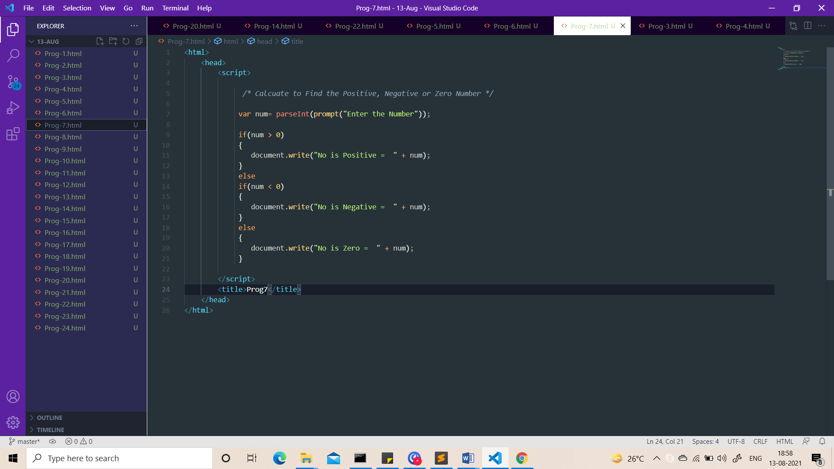

Output:-

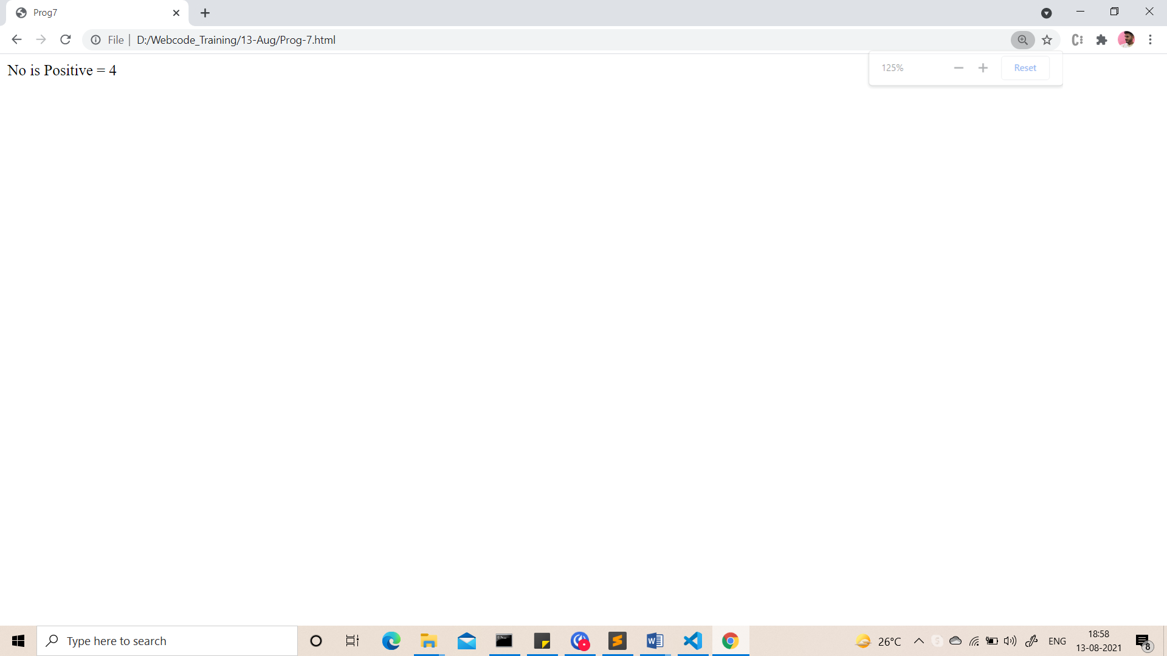

1. Take 2 numbers and display greatest number. (Also check equal number condition)

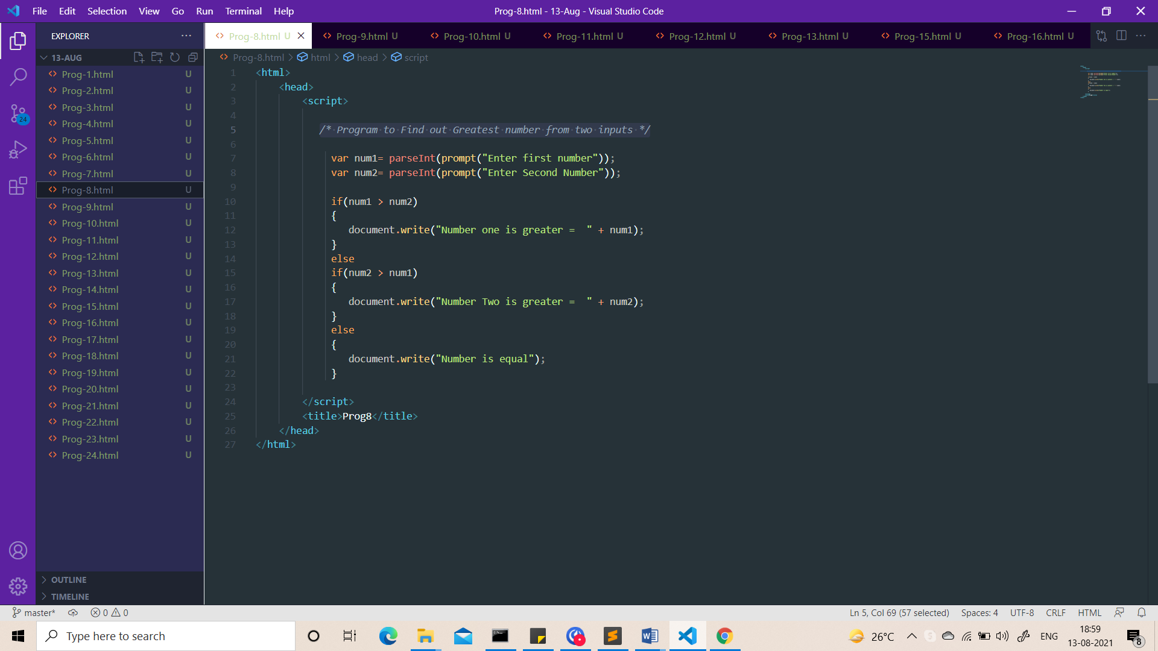

Output:-

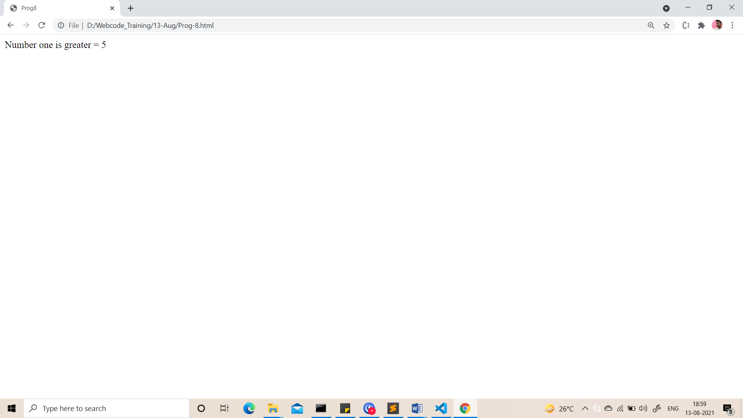

1. Take a number and find factorial of that number.

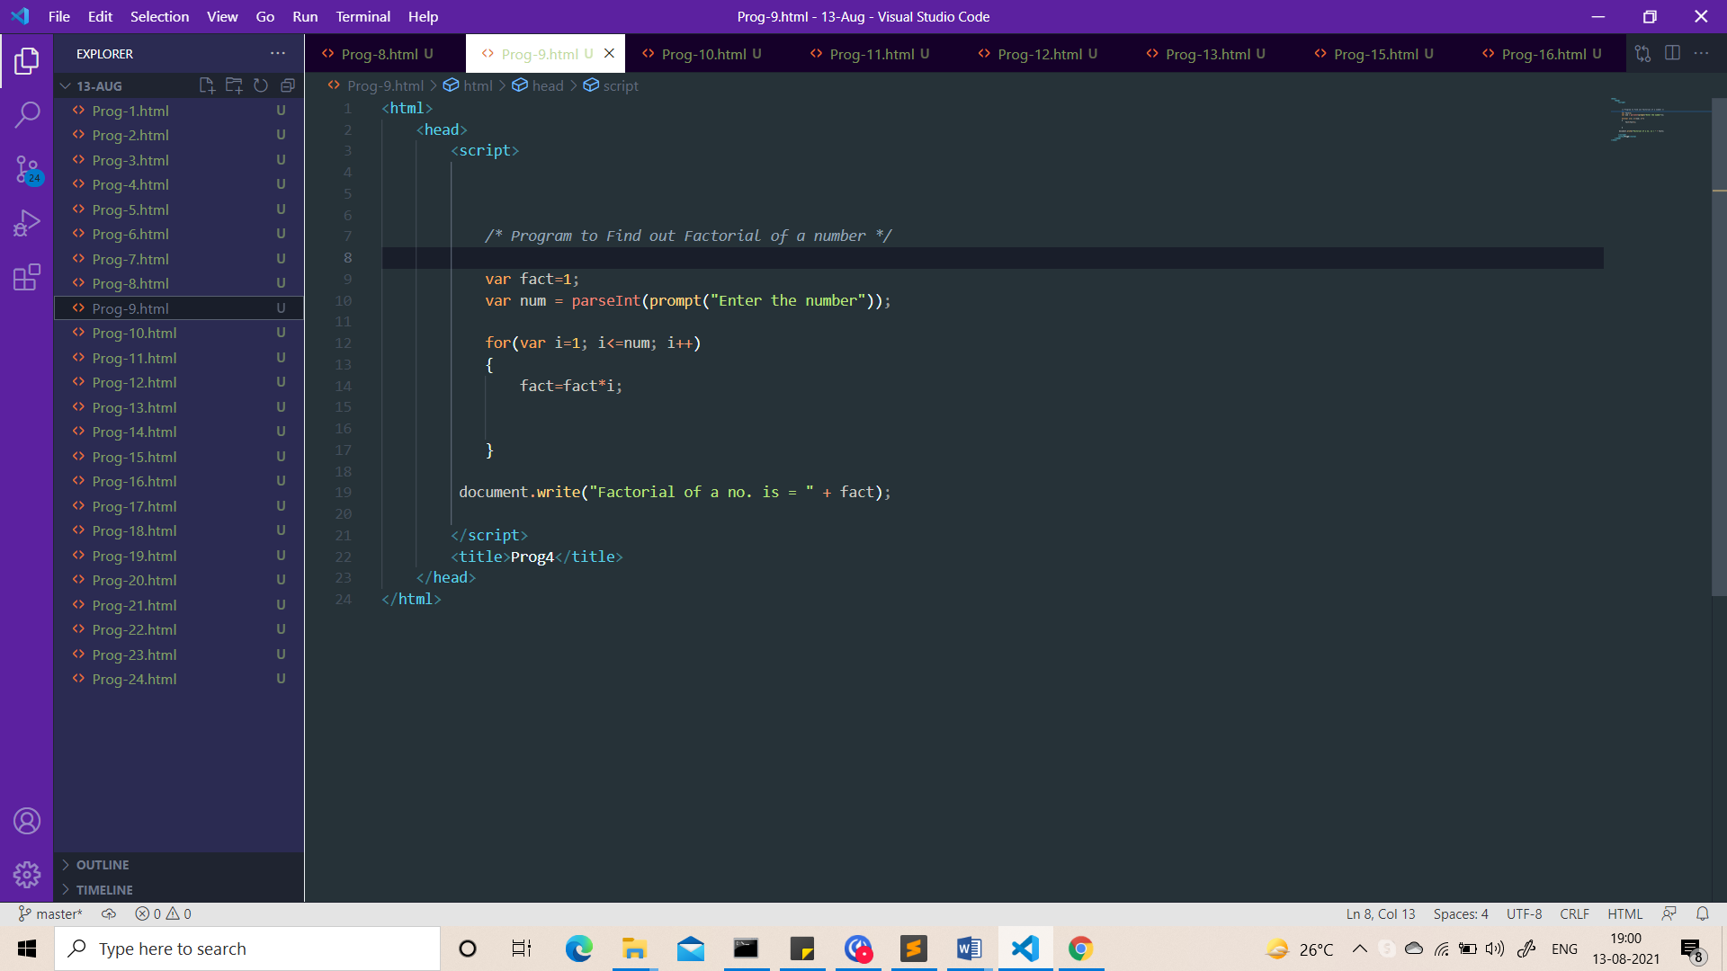

Output:-

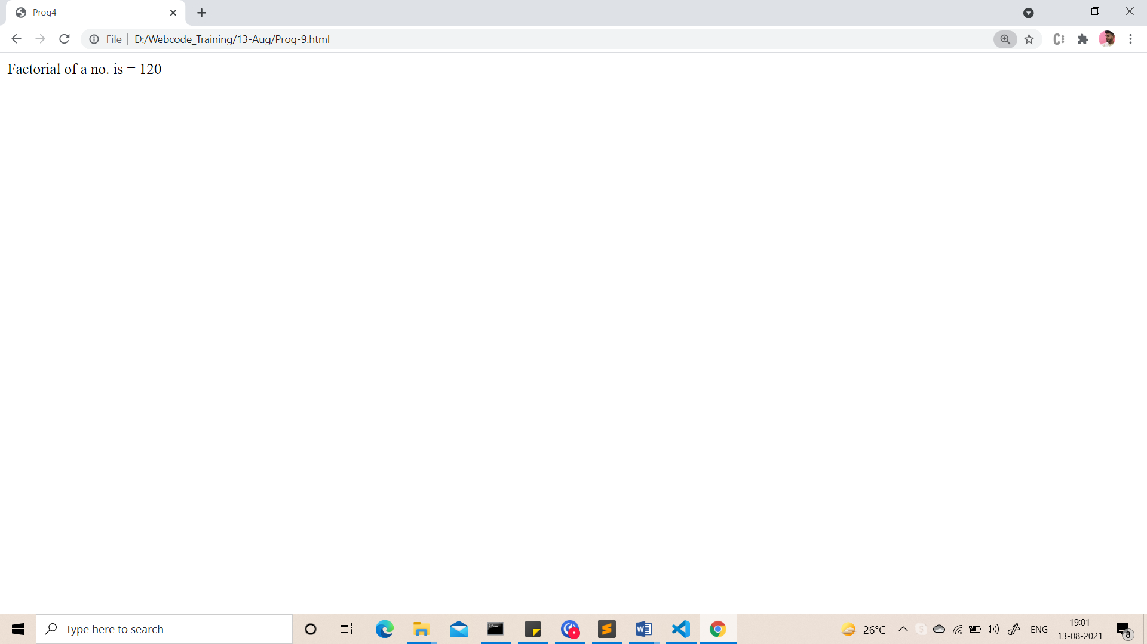

1. Write a program to swap 2 numbers using third variable.

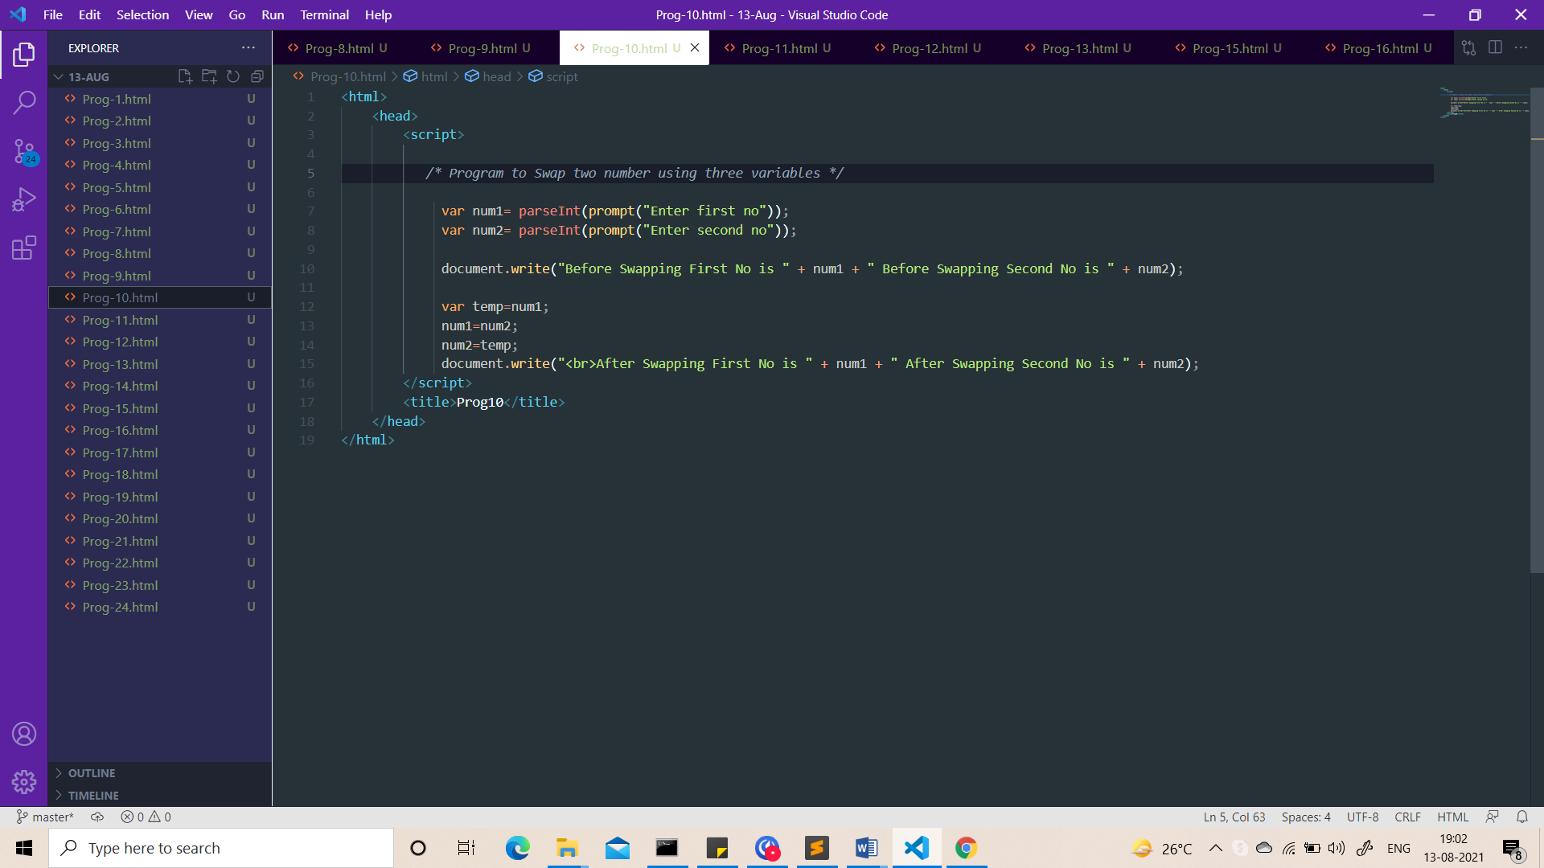

Output:-

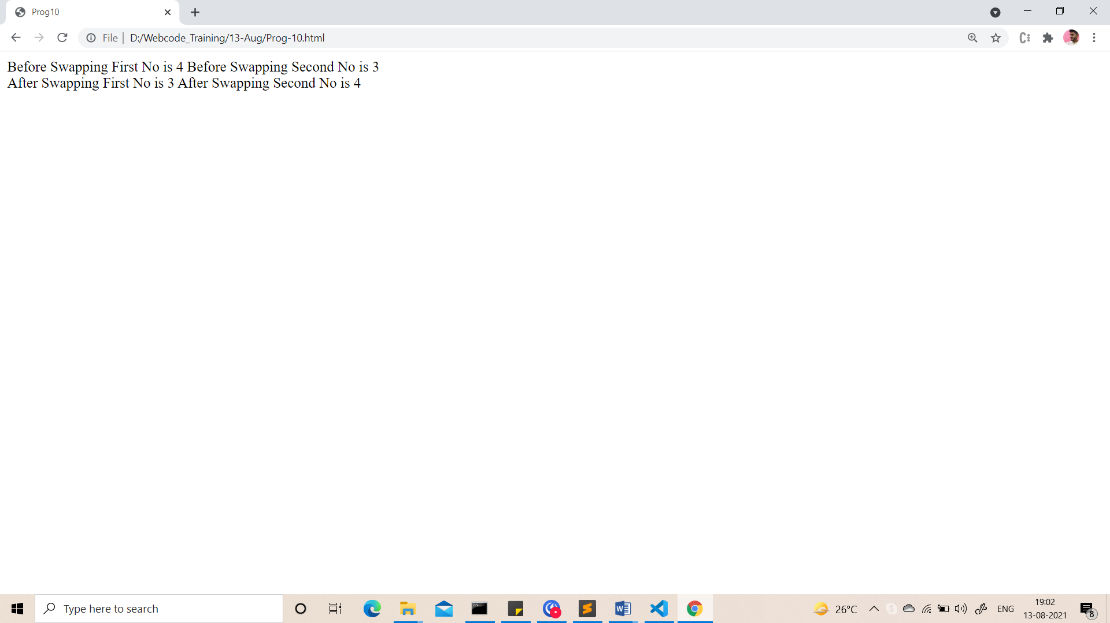

1. Take 2 numbers and find smallest number.

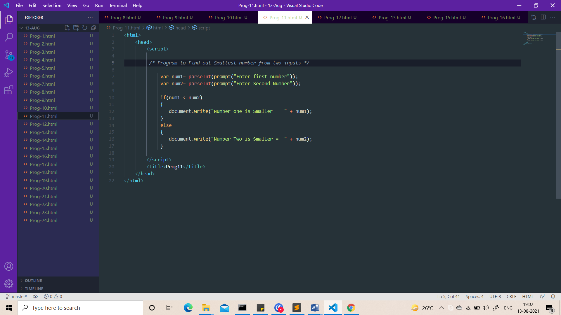

Output:-

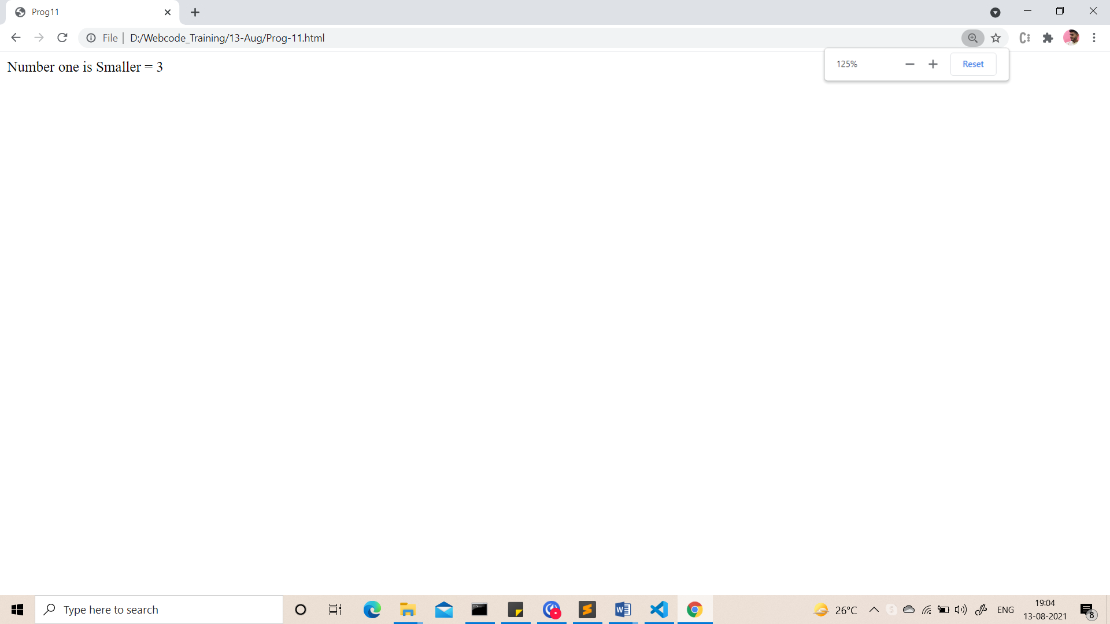

1. Take a number check if a number is less than 100 or not. If it is less than 100 then check if it is odd or even.

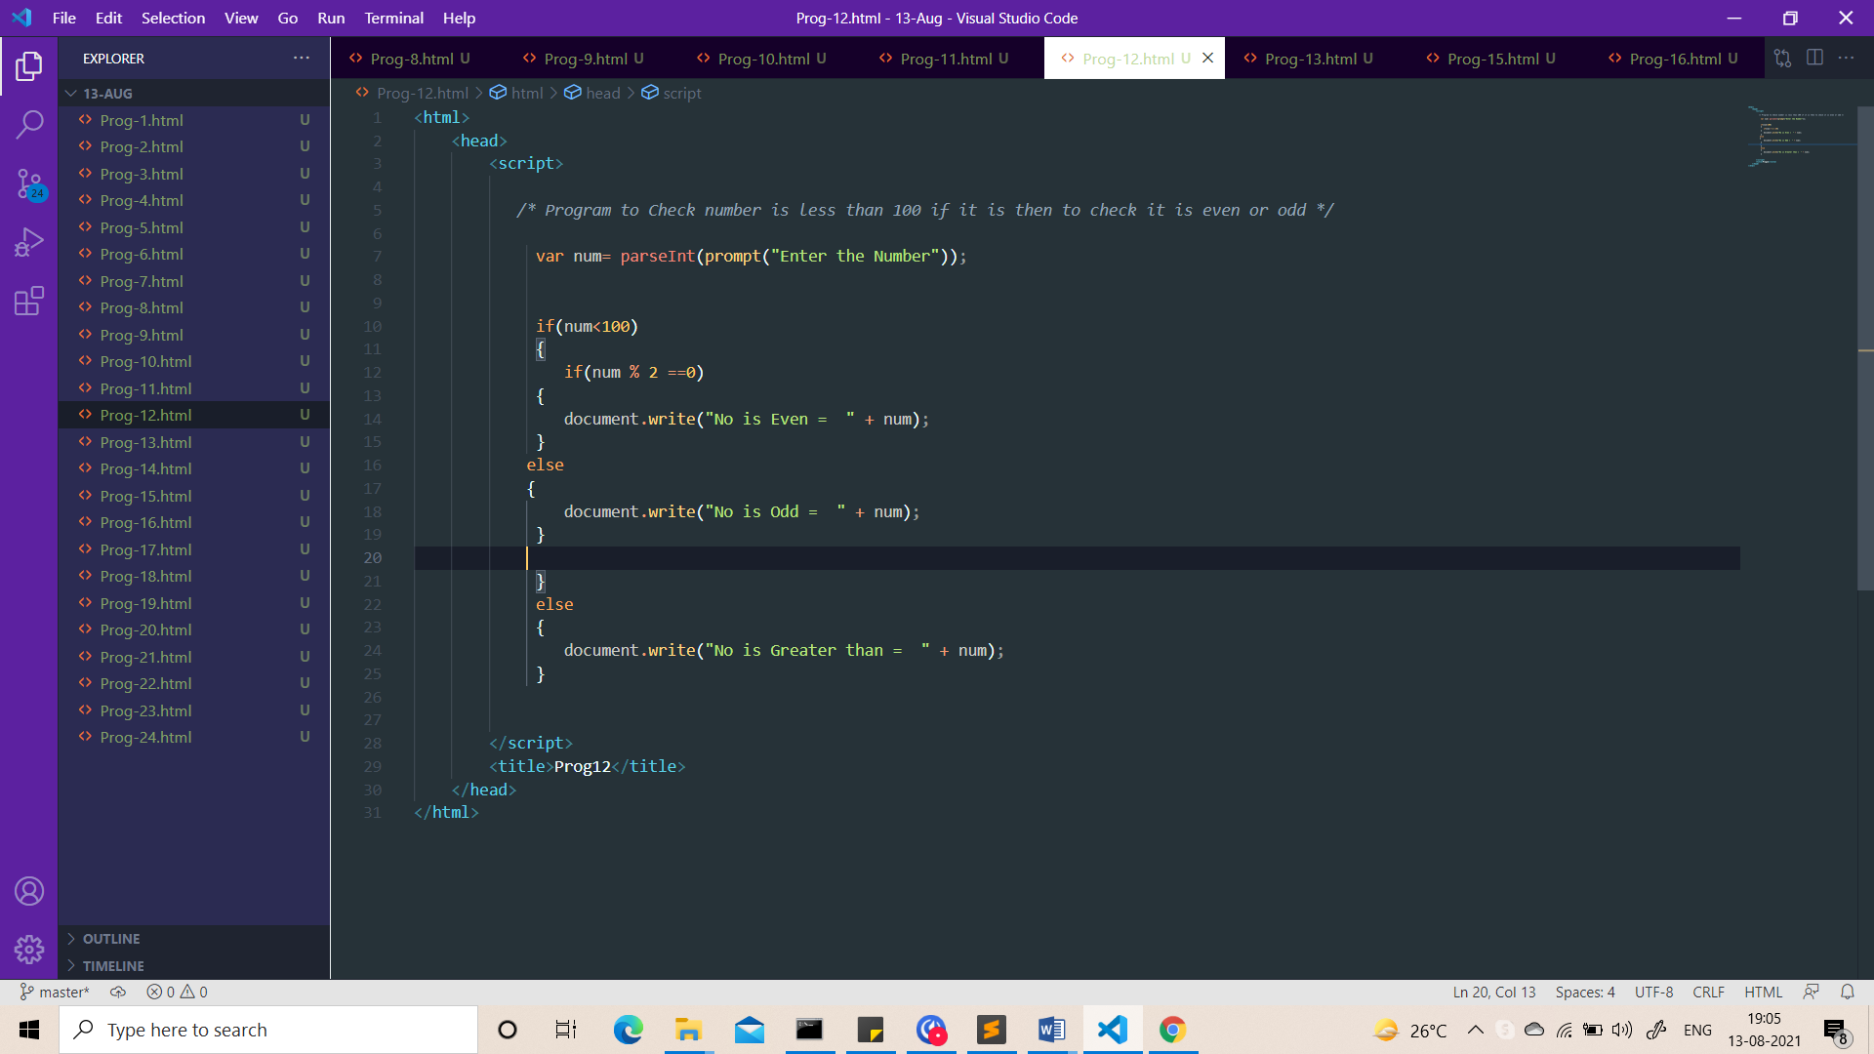

Output:-

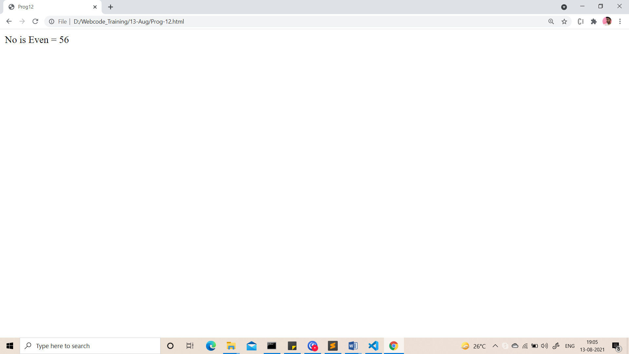

1. Take a number to print the square of a number if it is less than 10.

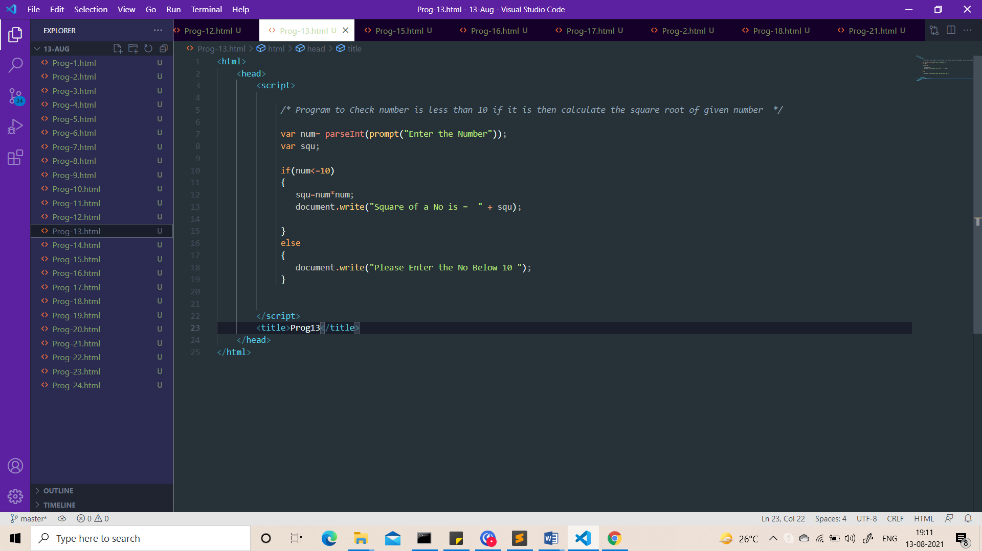

Output:-

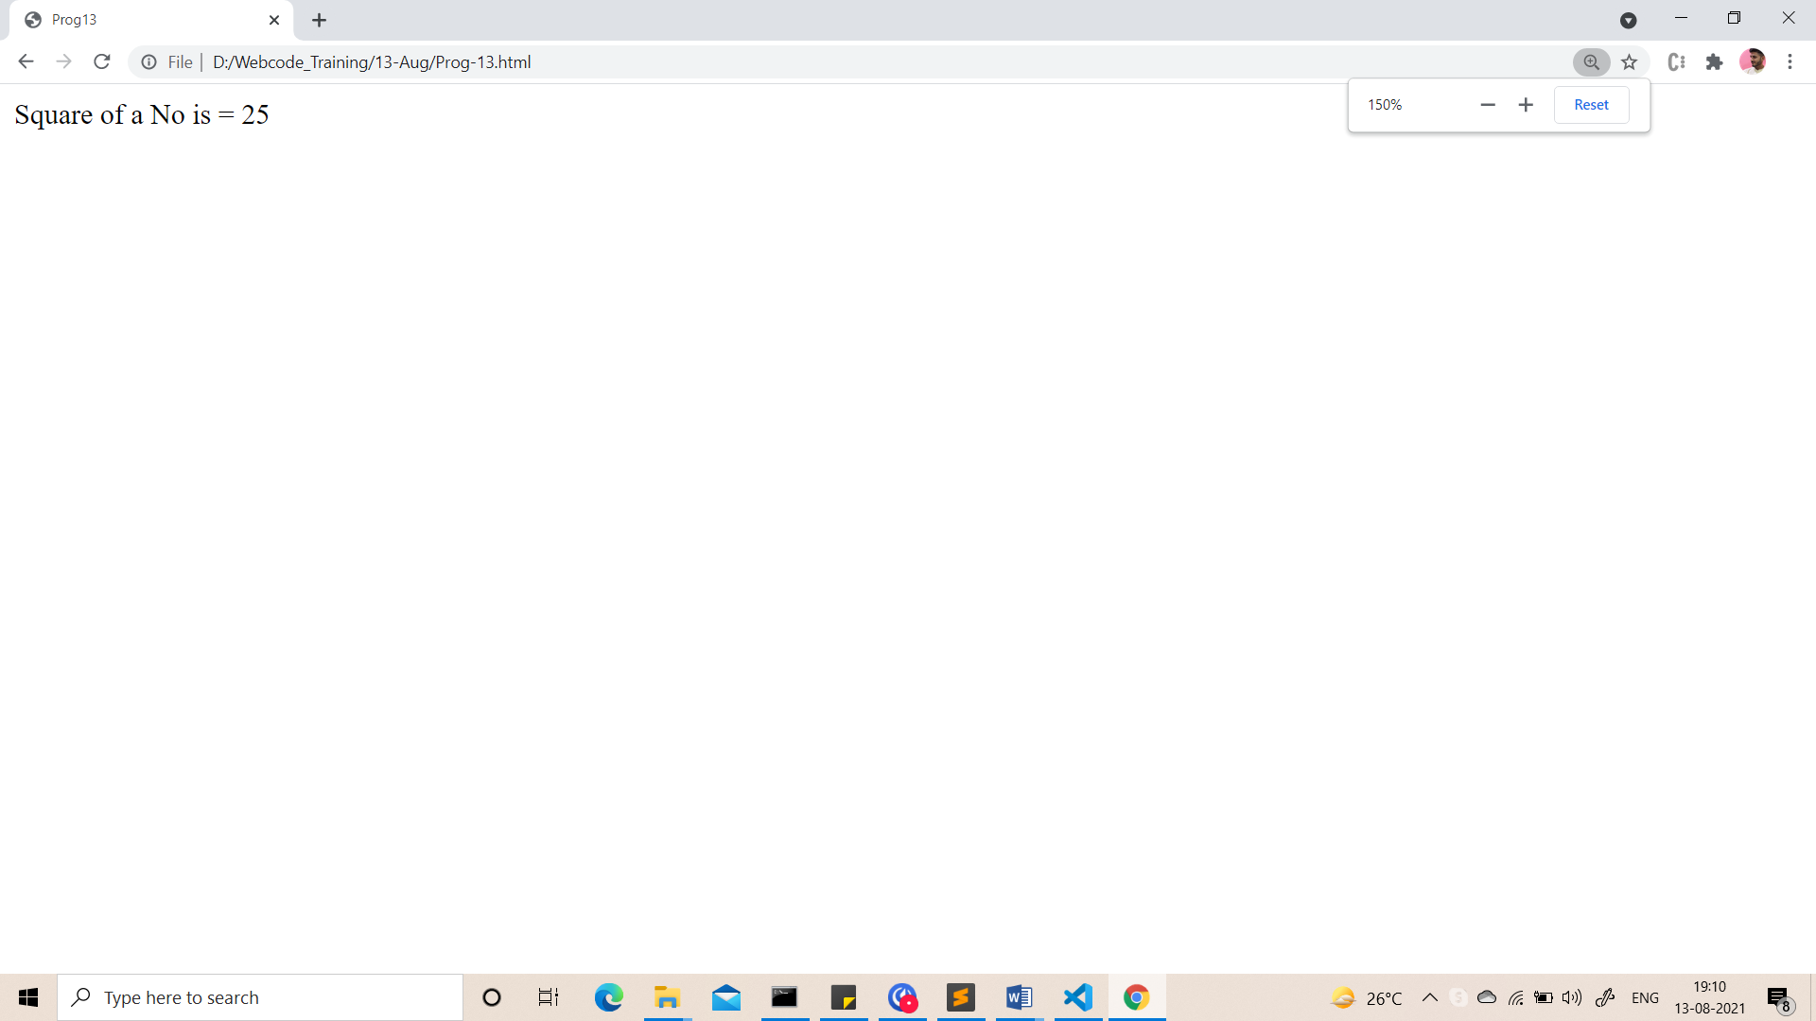

1. Take a number and check whether it is zero, positive or negative using nested IF…ELSE statement .

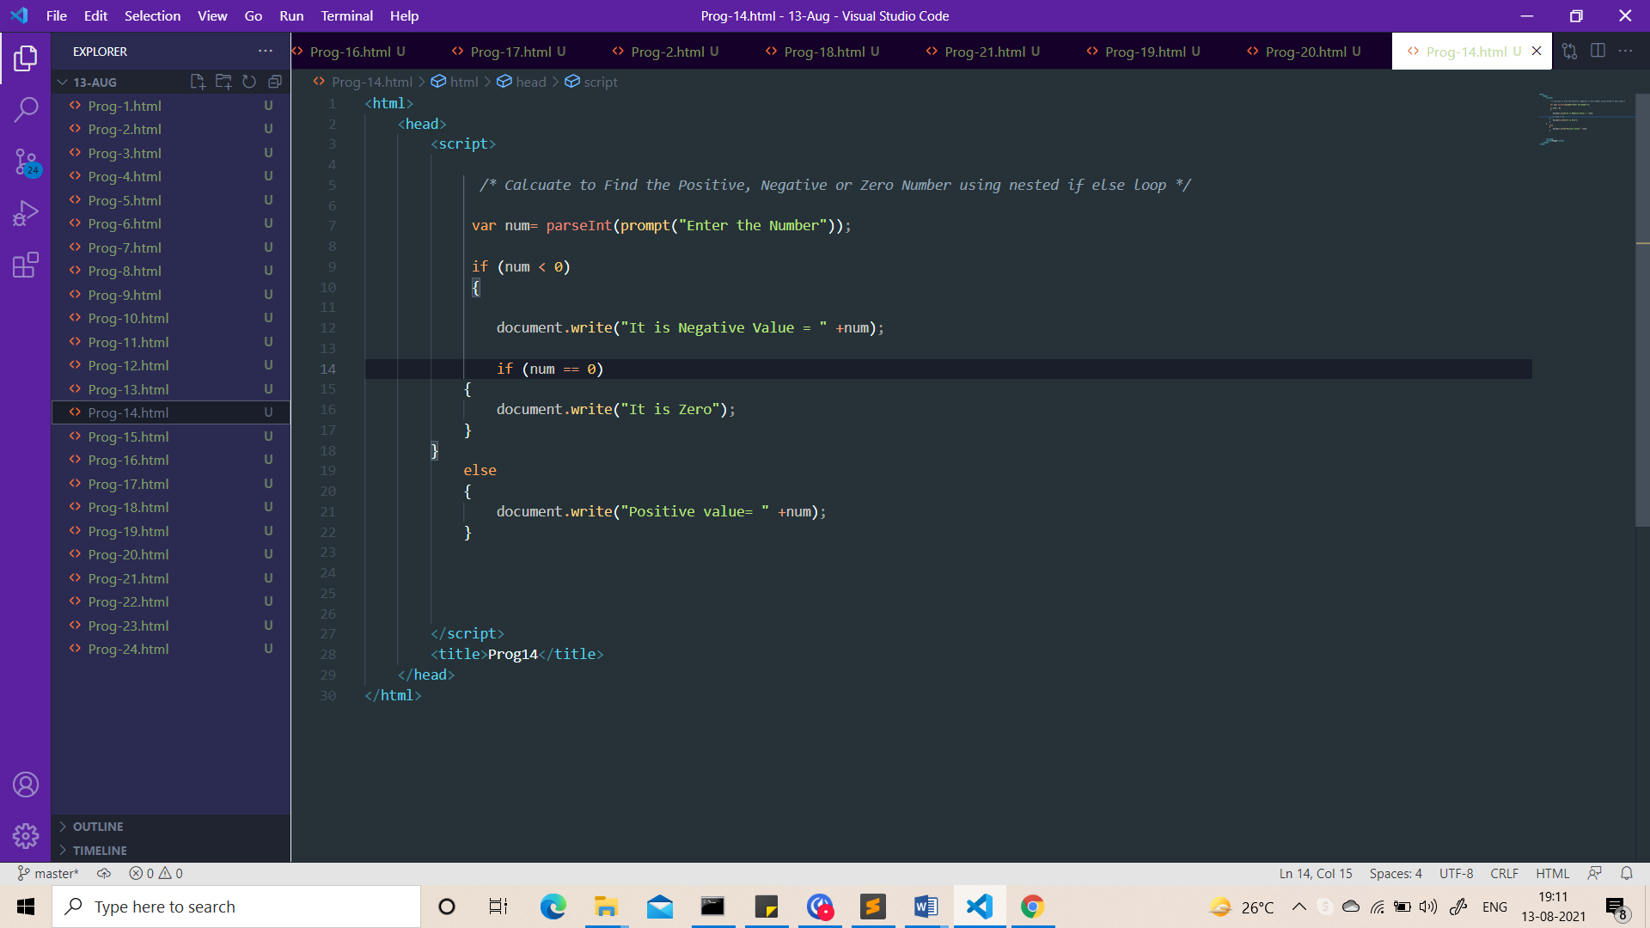

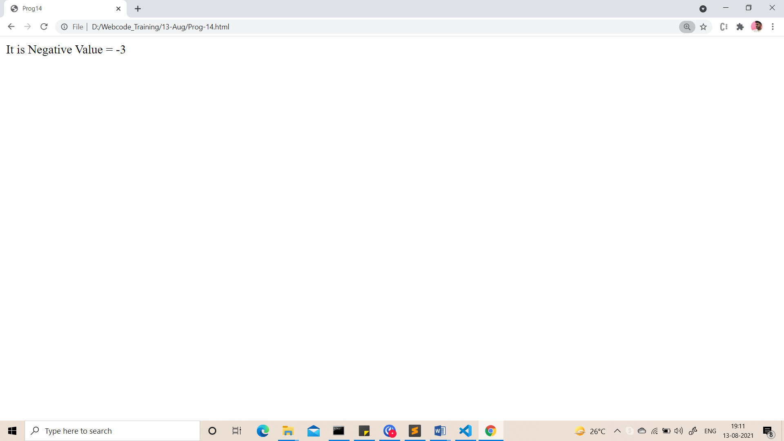

1. Take 3 numbers and find greatest number using nested IF….ELSE statement.

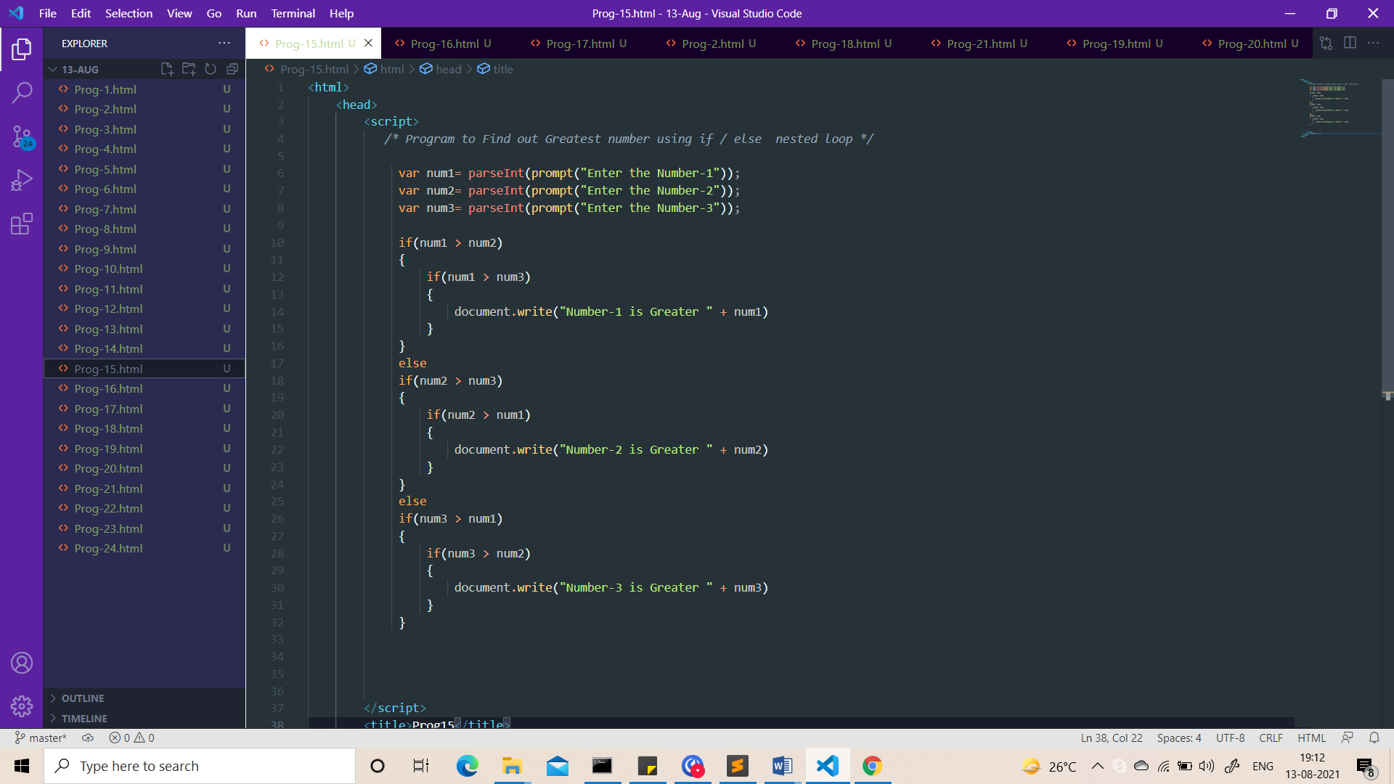

Output  
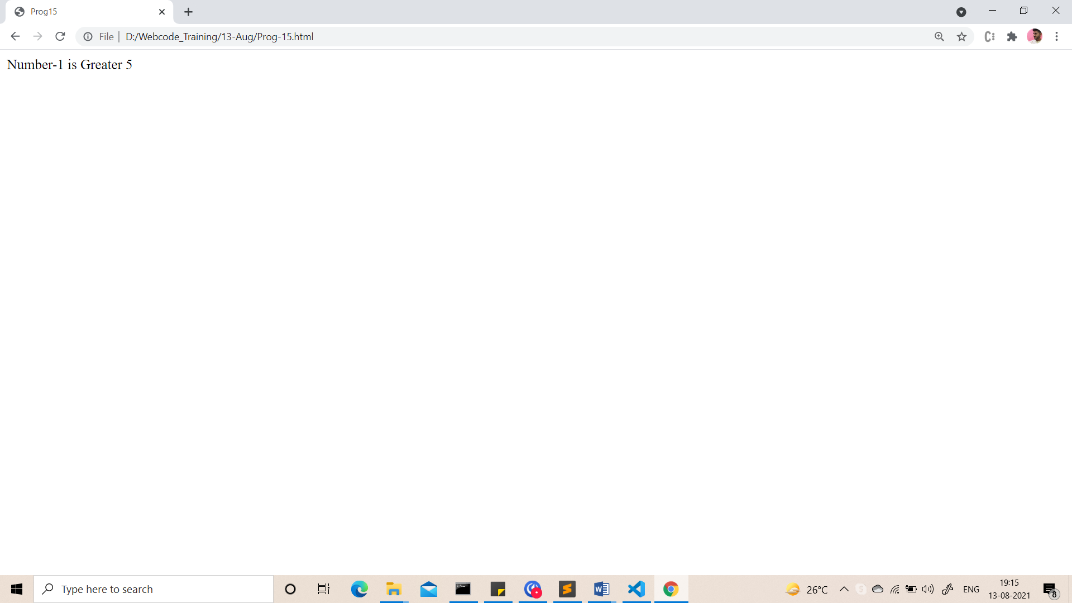

1. Take 3 numbers and find smallest number using logical operator.

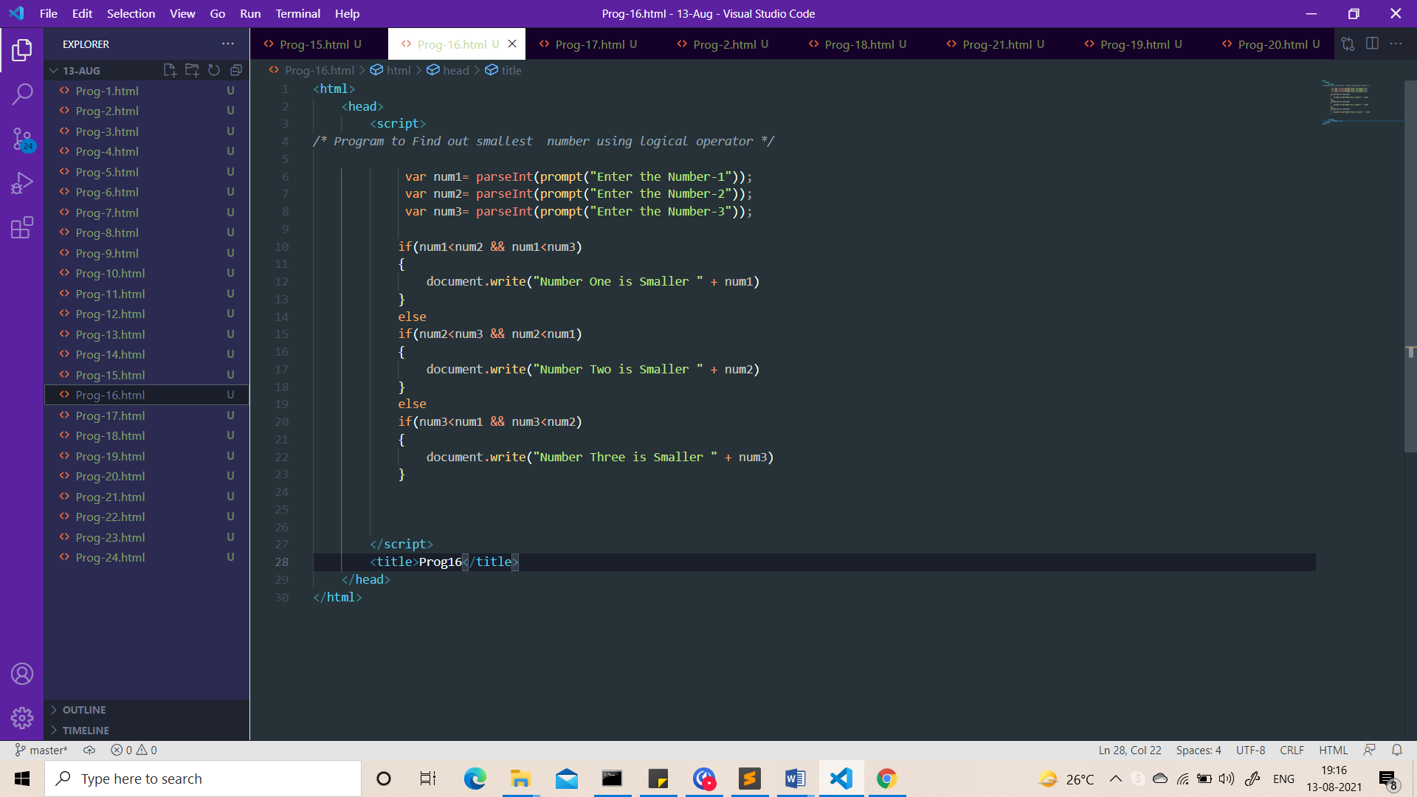

Output:-

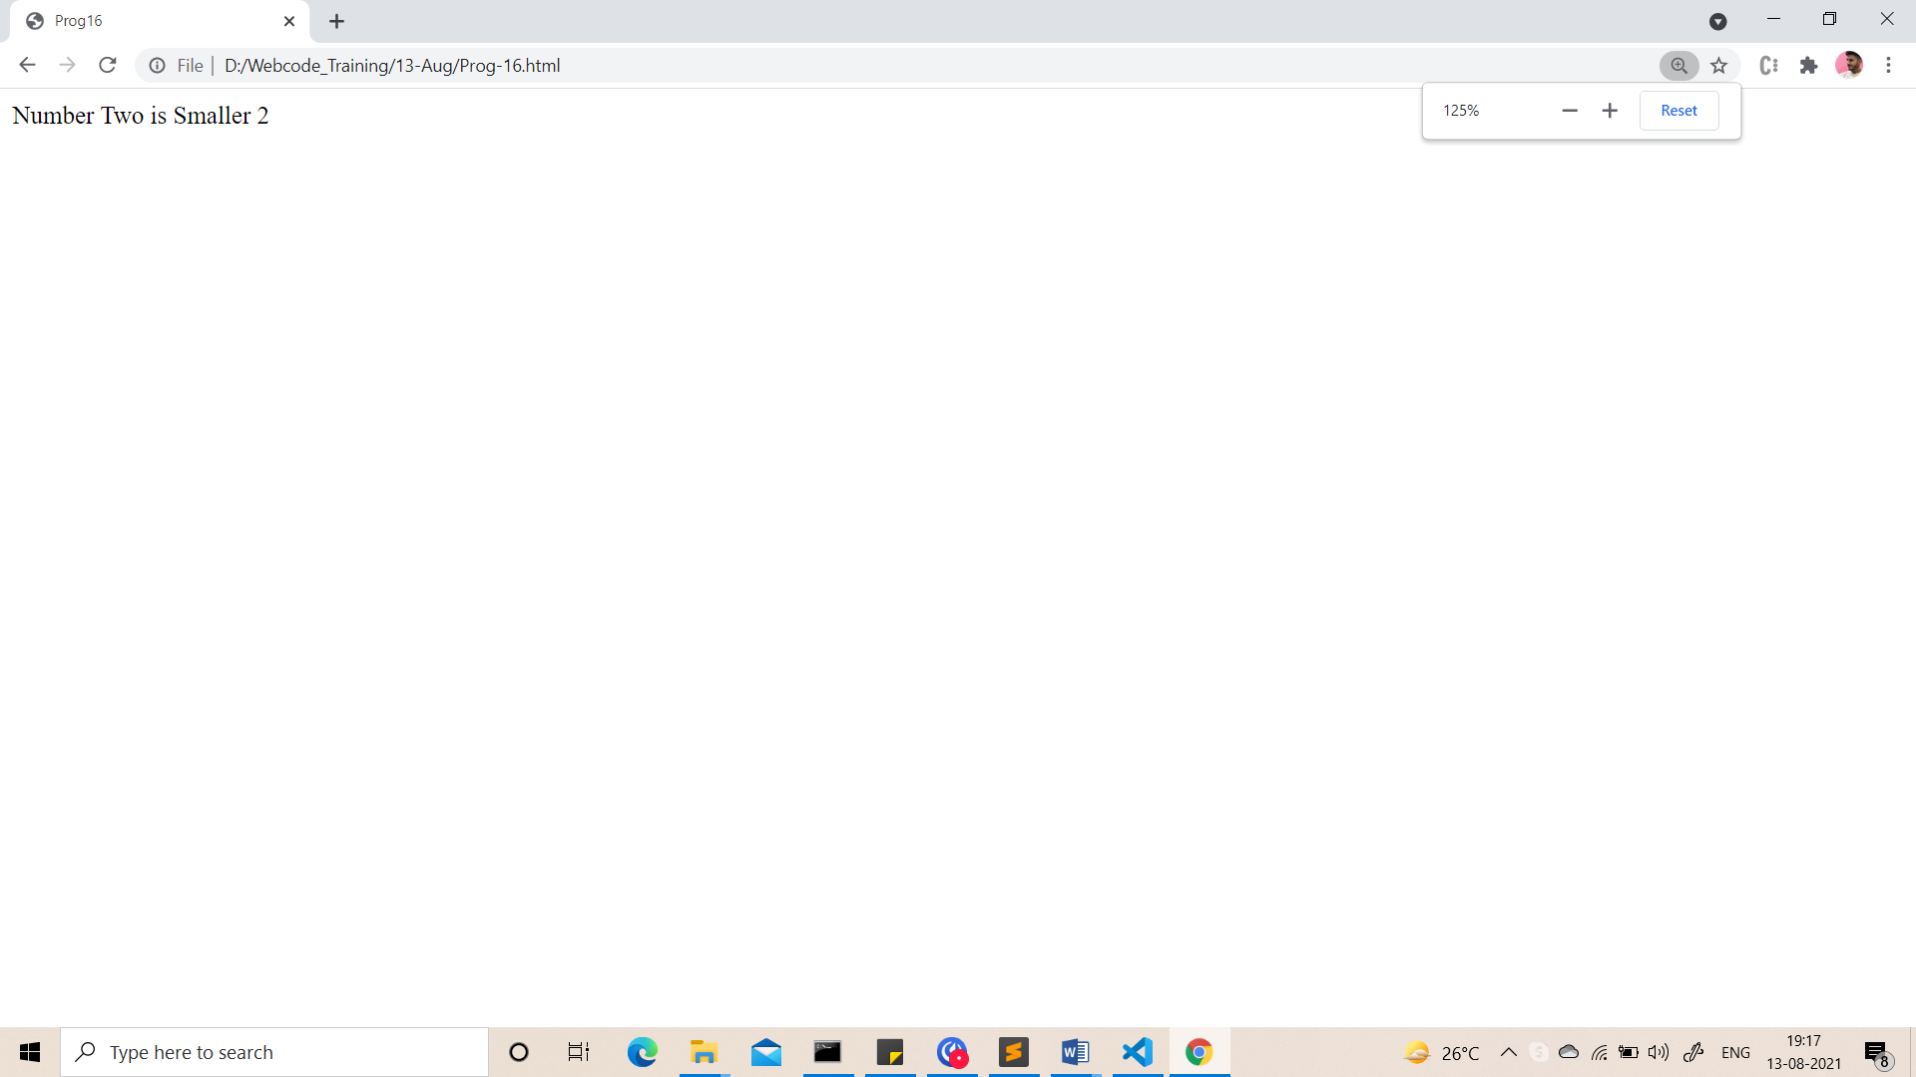

1. Write a program to swap 2 numbers without taking third variable.

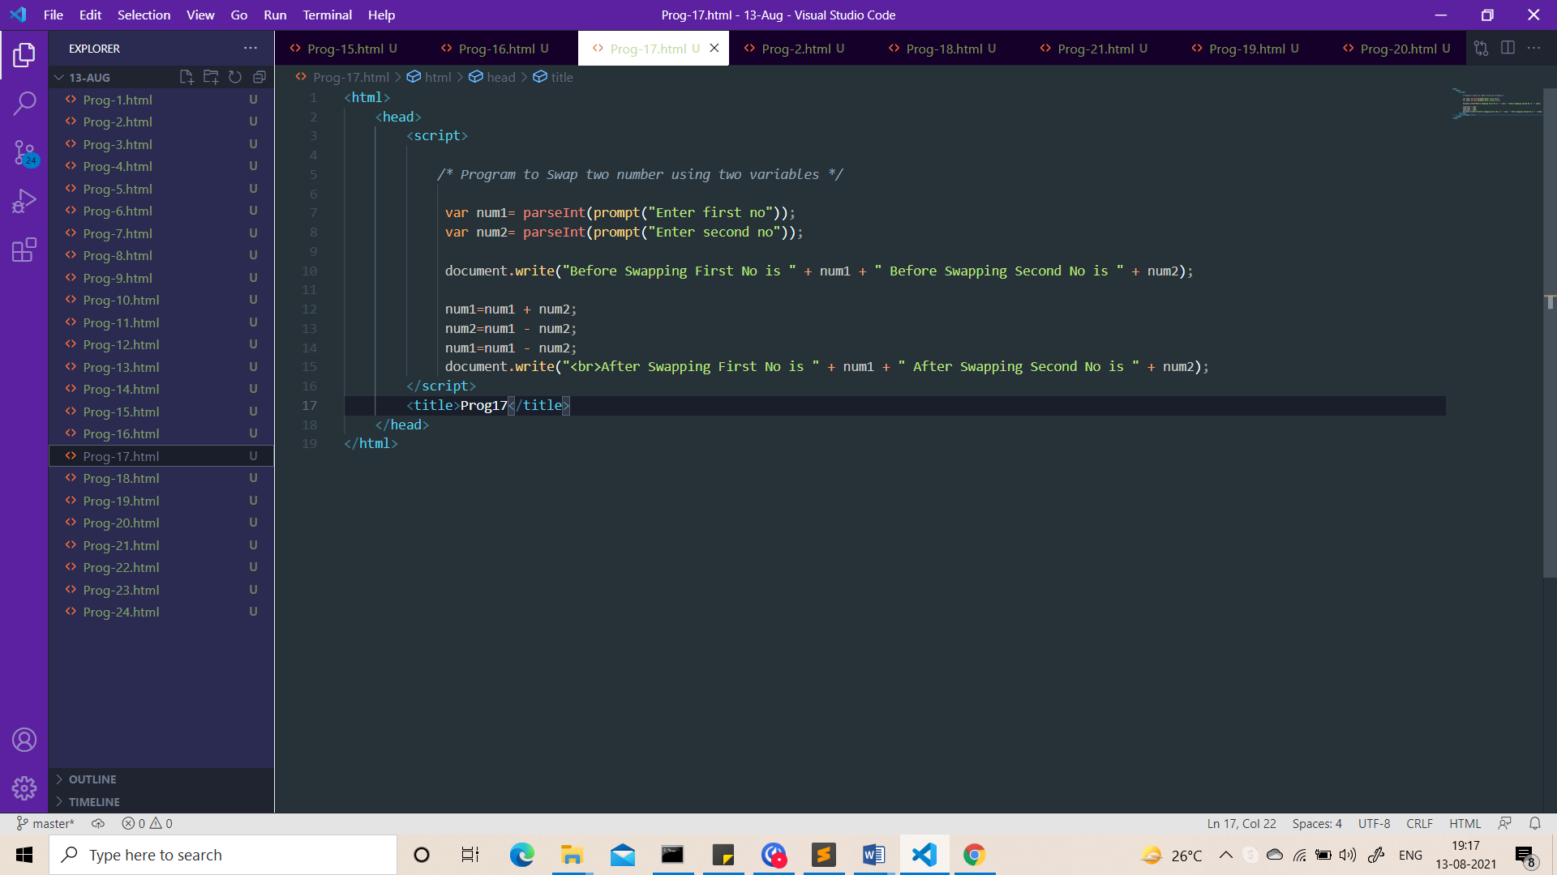

Output:-

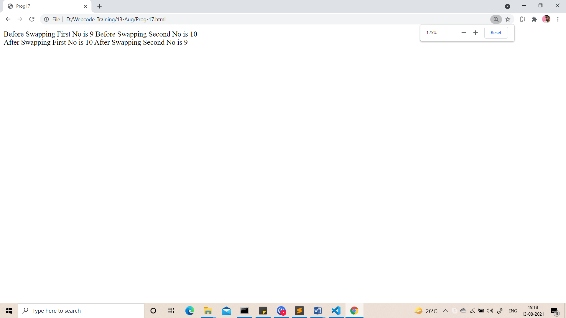

1. Write a program to check whether character is alphabet or not.

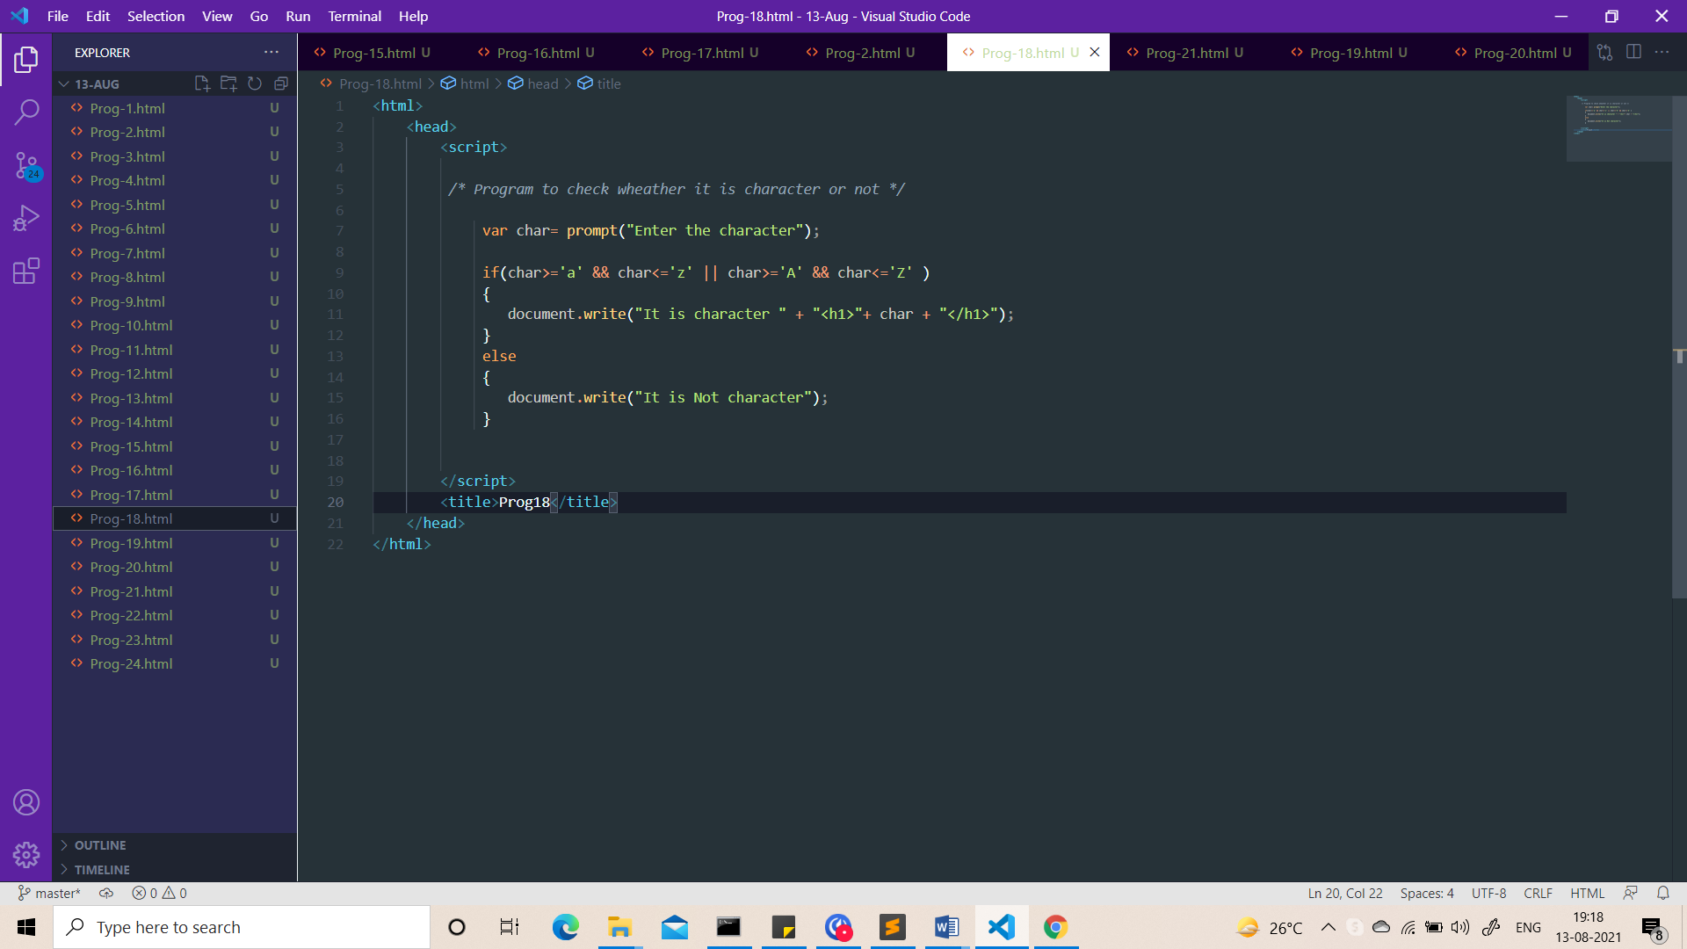

Output:-

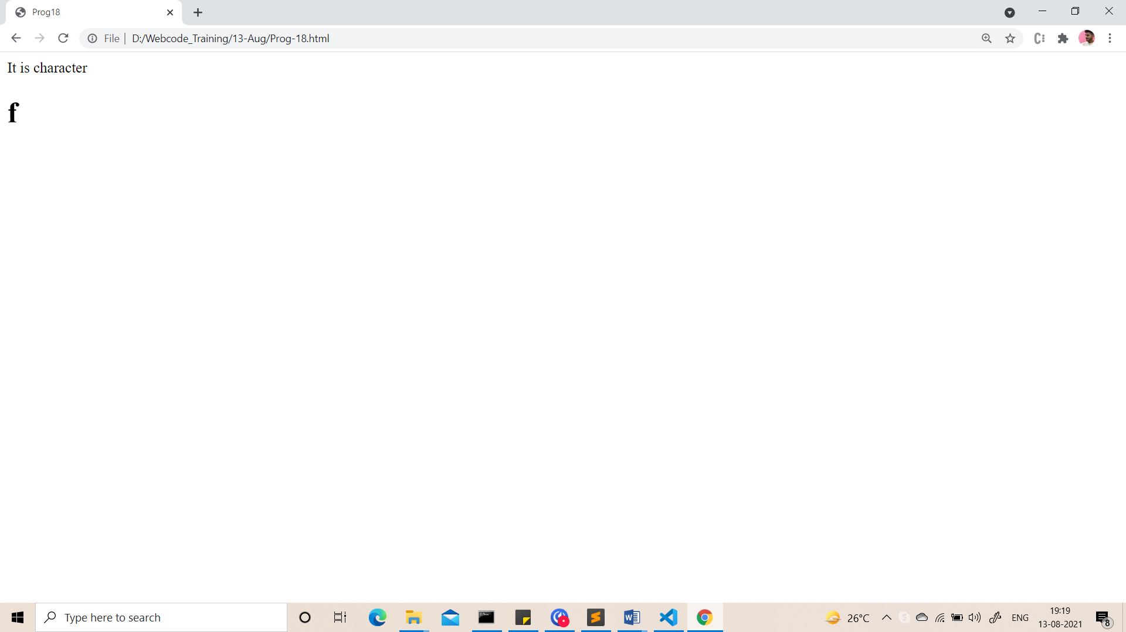

1. Take a number from the user. Take starting number & ending number from the user. Generate multiplication table of that number.

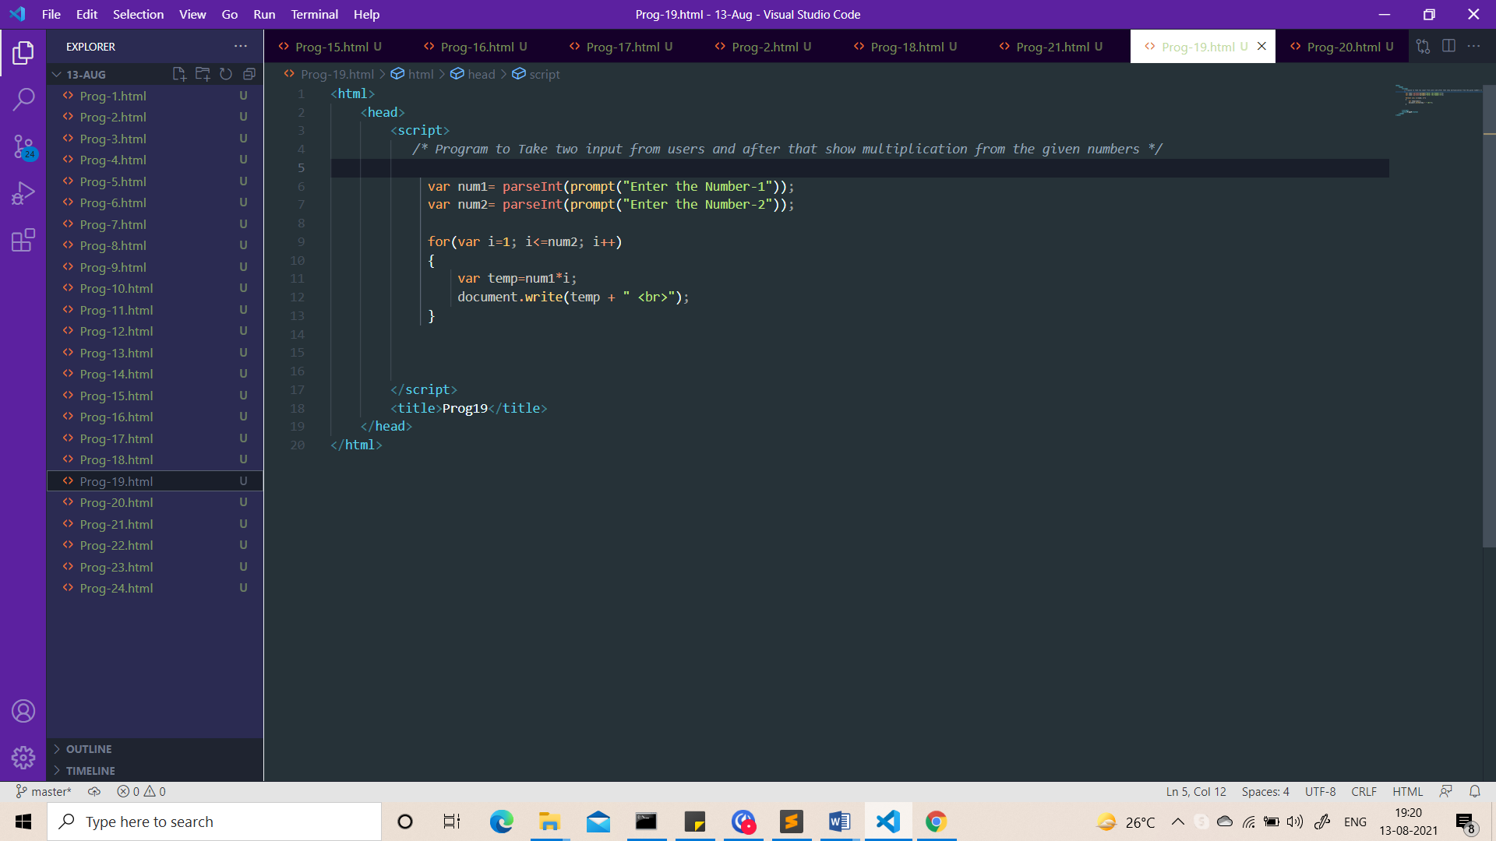

Output:-

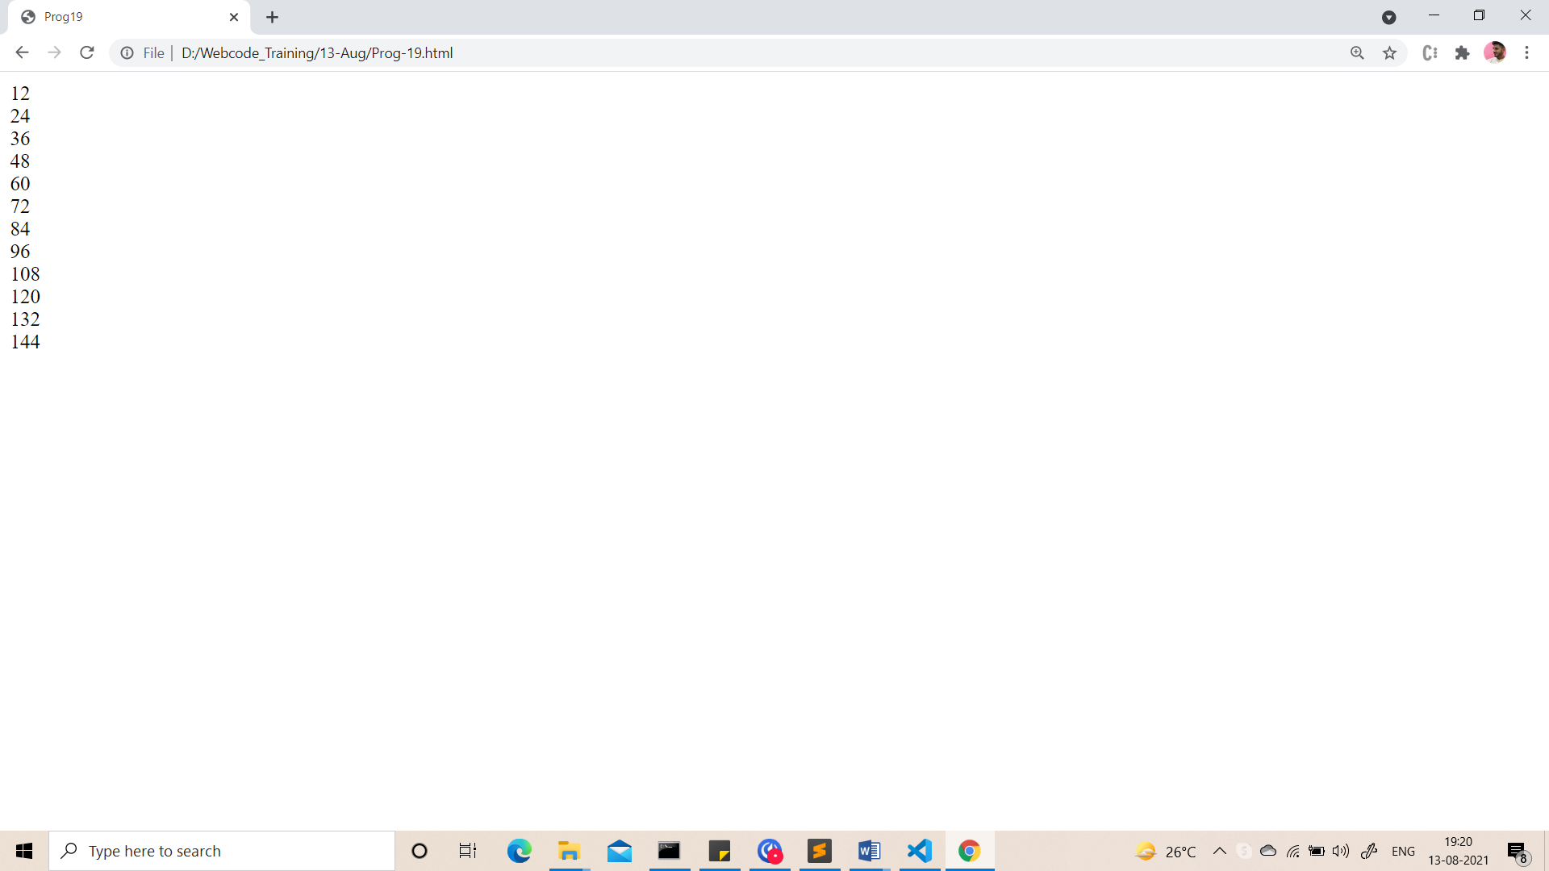

1. Take a number and calculate sum of natural numbers.

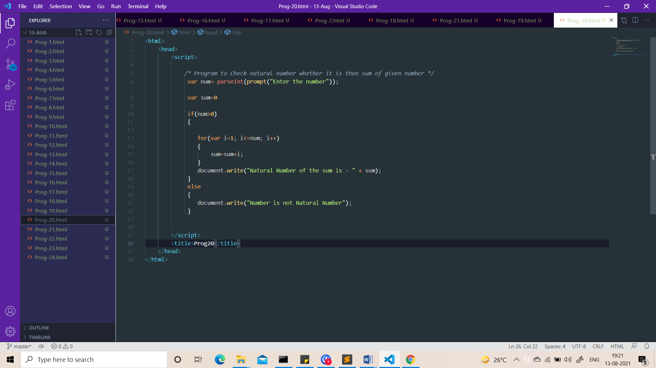

Output:-

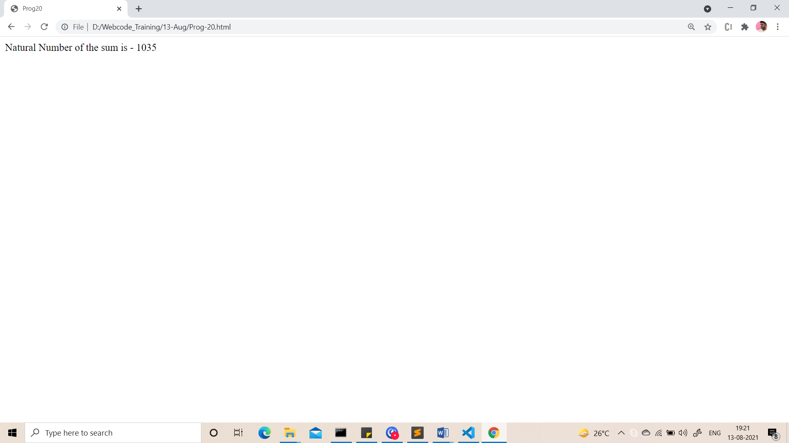

1. Write a program to display Alphabets.

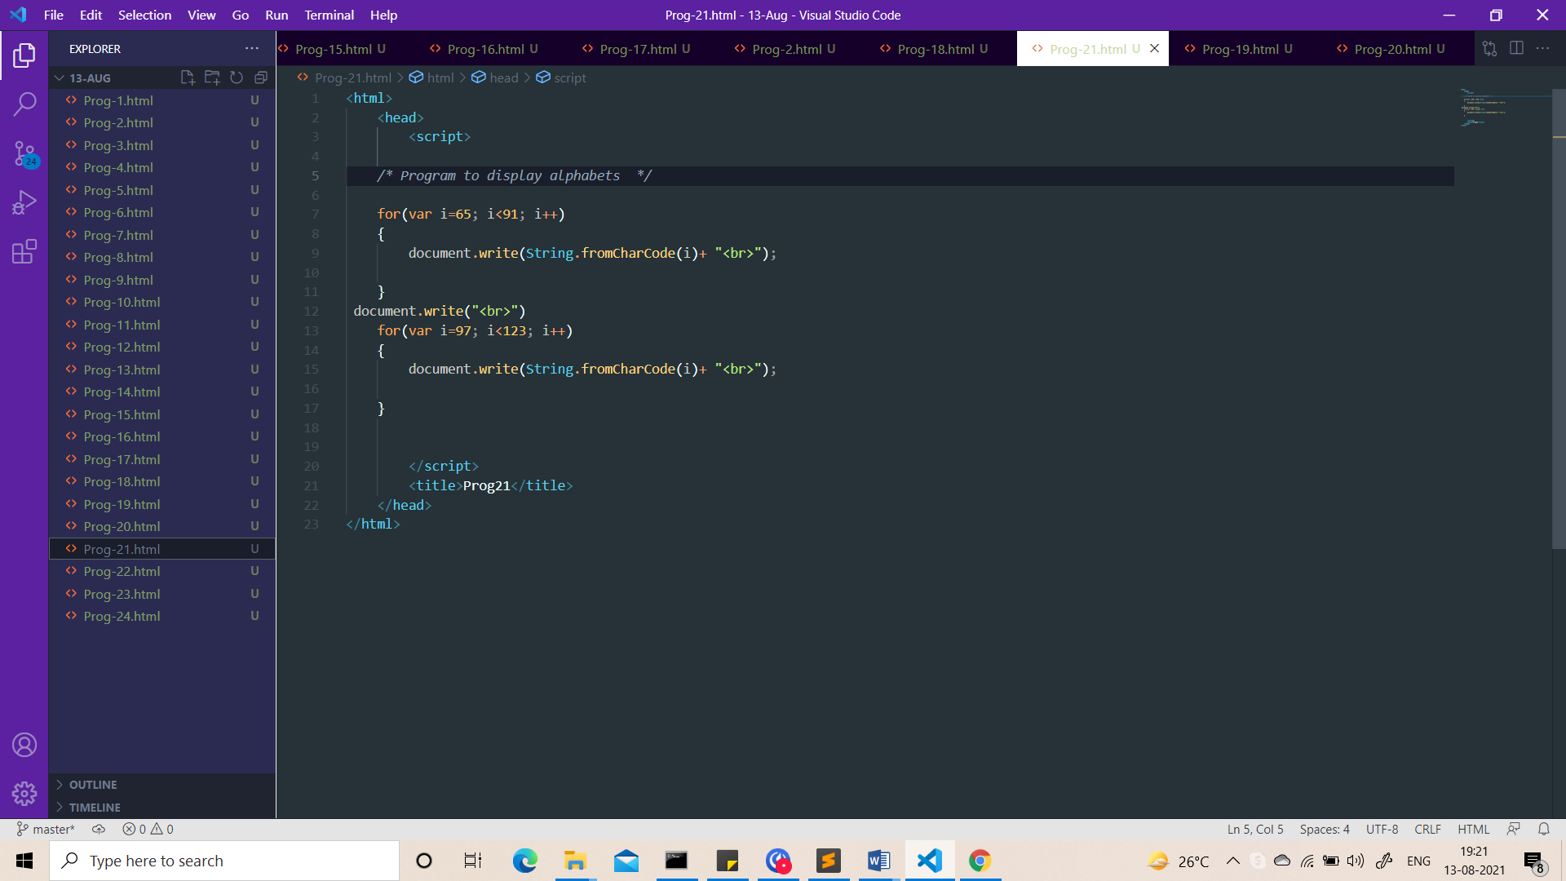

Output:-

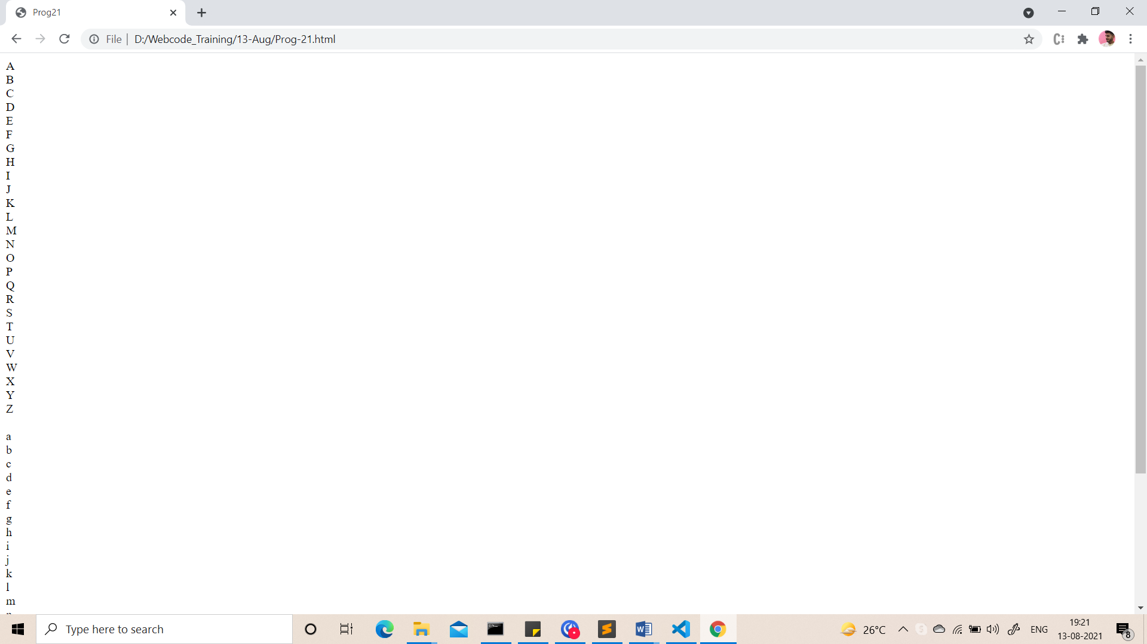

1. Make a simple calculator using switch case-
   1. 1.Addition
   2. 2.Subtraction
   3. 3.Multiplication
   4. 4.Division

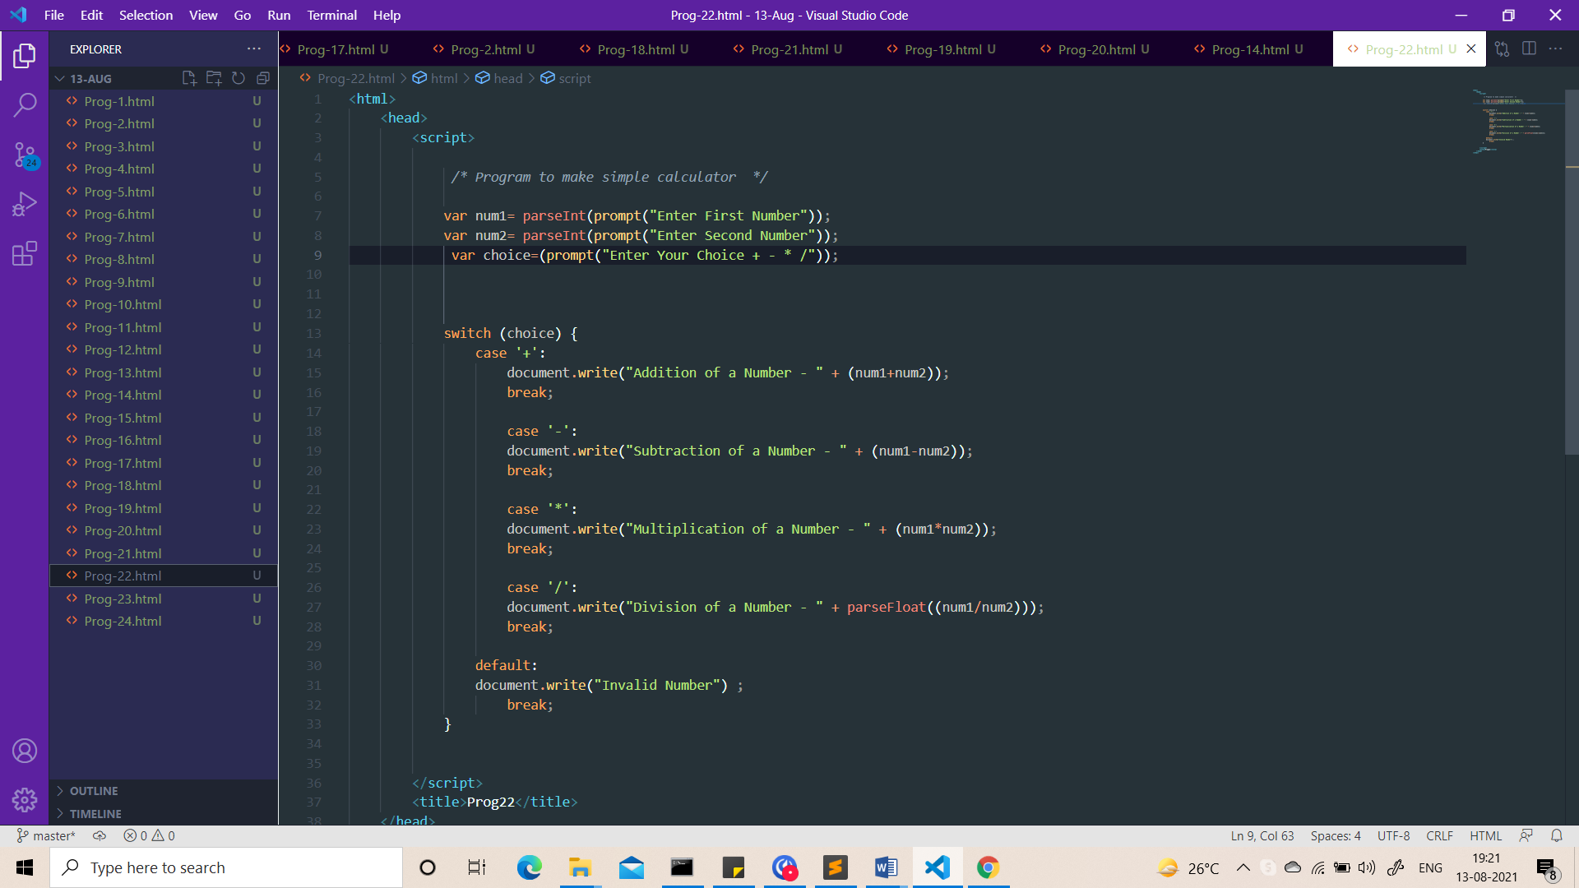

Output:-

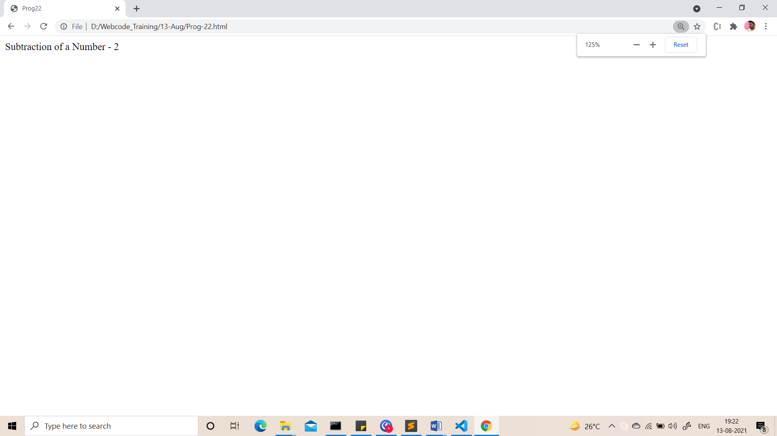

1. Take 5 numbers and calculate percentage. According to that percentage print grade.

* If marks <50 then **Grade** is F.
* if marks >=50 <60 then **Grade** is D.
* if marks >=60 <70 then **Grade** is **C**.
* if marks >=70 <80 then **Grade** is B.
* if marks >=80 <90 then **Grade** is A.
* if marks >=90 then **Grade** is A+

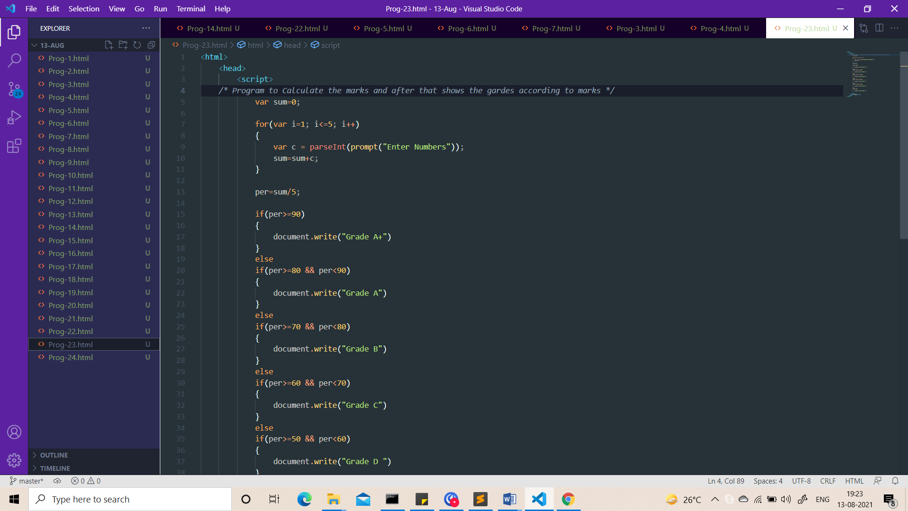

Output:-

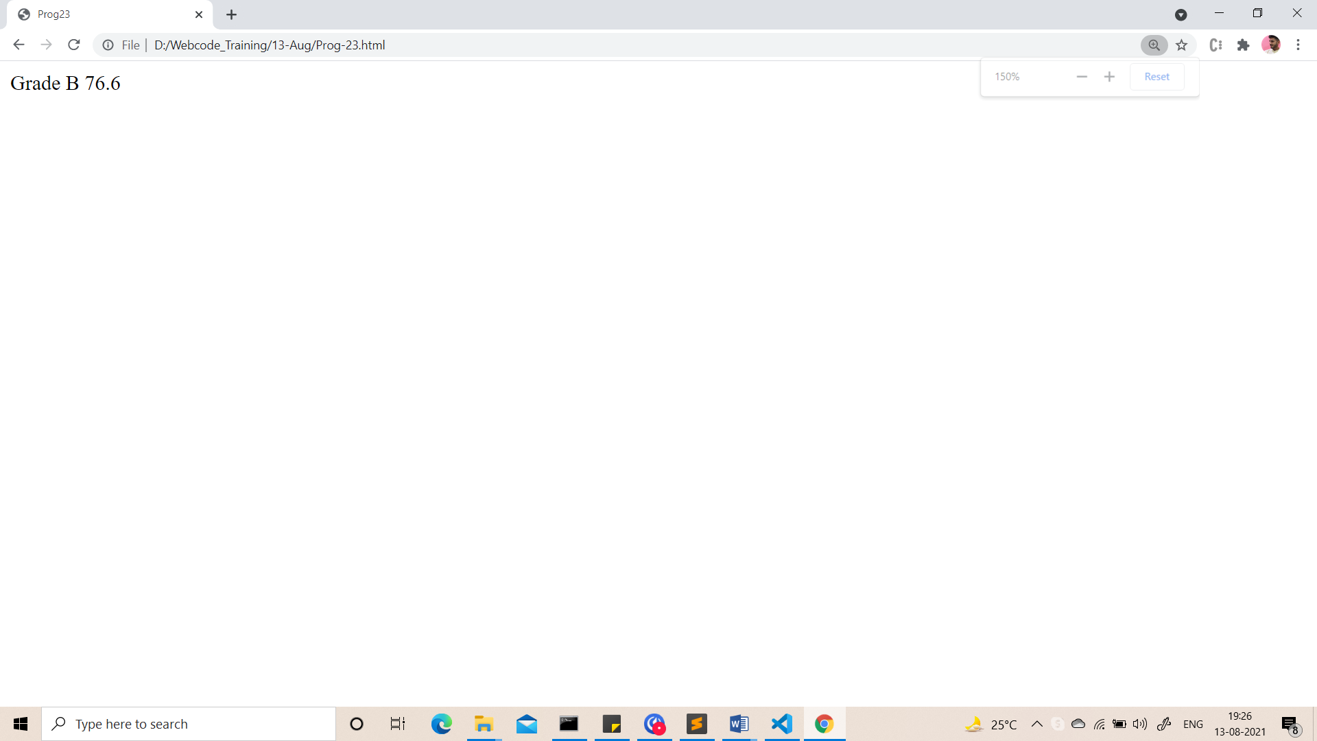

1. Take starting number and ending number from the user and print following series.

Output :-

Enter starting number : 30

Enter ending number : 0

30

27

24

21

18

15

12

9

6

3

0

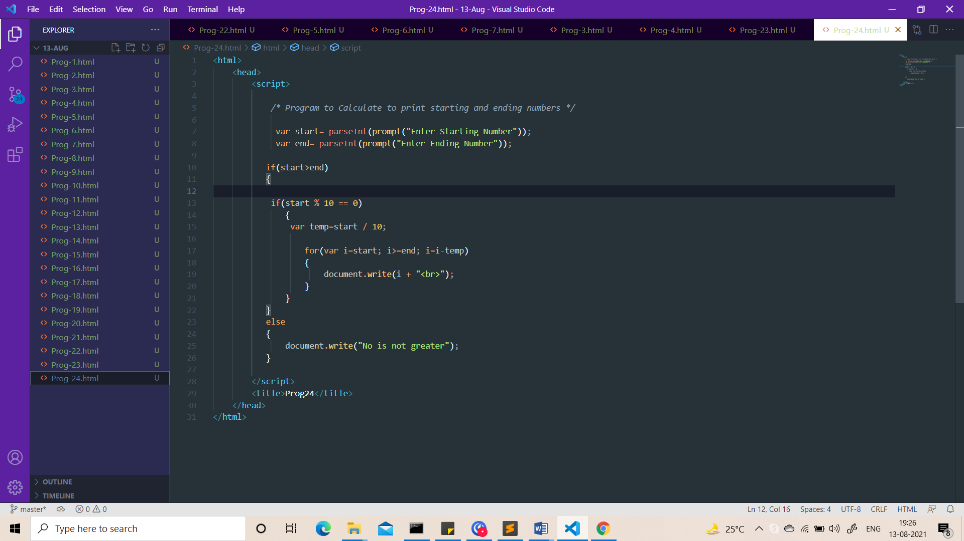

Output:-

